An Overview of The Emissions and Renewable Energy use of European Countries

Ben Miller

@00498625

# Part One: Dashboard Design

# Introduction

Renewable energy is clean power, which is produced from natural resources like, the light from the sun or wind. Renewable energy is clean energy as it doesn’t produce pollution and is produced by such technologies like wind turbines, solar panels, hydro-electric plants and **floating turbine platforms. In 2018, 33% of the electricity in the UK was produced by renewable sources and has increased to 37.4% in the first quarter of 2019.** EnAppSys predicts that if current trends continue, renewables will be the UK’s top power source. Wind and solar have the potential to generate 121.3TWh or electricity over the calendar year of 2020, pushing ahead of declining coal and gas-fired power sources (Smarter Business, 2019).

In the world, most of the electricity comes from coal, nuclear, and other non-renewable power plants. Producing this energy pollutes the air, land and water and assists global warming. More renewable sources instead of ordinary electricity generation would decrease the amount of sulphur dioxide, CO2 and particulate matter in the atmosphere which would in turn decrease the health implications like lung cancer and respiratory issues. Furthermore, it would decrease global warming and reduce the destruction of the atmosphere which protects us from the Sun’s harmful rays (Center for Resource Solutions , 2020). It is essential to prioritise renewable energy. Wind energy may save 342 million tonnes of CO2, which is comparable to removing 80 percent of the EU's automobile fleet off the road and saving €8.5 billion in CO2 expenses. Wind energy is expected to save 646 million tonnes of CO2 by 2030, which is comparable to removing 152 percent of the EU's automobile fleet off the road and saving around € 26 billion in CO2 expenditures. (EWEA, 2016).

In this paper, emissions data and electrical power use across 15 European countries will be investigated. The purpose is to look at how clean these countries are and what countries could be doing better or progressing to become greener. A main problem that’s going to be investigated in this paper is the effect of renewable energy use has on emissions. As a result, the objective for this paper are as follows,

* Obtain a dataset on the emissions and power use for 15 European countries. This is obtained off The World Bank database and then cleaned manually using Microsoft excel. The dataset should be transposed and prepared ready for importation into Tabula.
* Preform a background investigation on the use and effectiveness of dashboard. What make them useful and how using certain feature or techniques makes the dashboard more effective. In addition, an investigation and overview on the methodologies of creating a dashboard. In additions, to perform background research on the statistical methodologies mentioned in the section 4 of the assessment.
* Next is to create a dashboard around the emission and power use of the 15 European countries. This will be completed in Tabula ensuring to use data visualization techniques. A few graphs that will be completed are, to create a time series graph on the greenhouse gasses and a bar chart on the percentage production of electricity from coal, oil and gas sources for all the 15 European countries. The objective of the final dashboard is to create an overview of the energy and emission use of these individual countries.
* Conduct the statistical analysis on the chosen dataset. Completing a comprehensive descriptive statistical analysis (e.g., Mean, Median, Mode, Standard deviation, Skewness and Kurtosis) on the data. Doing a correlation analysis for the indicators and see how the greenhouse gases correlate with the use of renewable energy. Doing a regression analysis, explaining why the selected regression technique is better for the defined objective and compare to any similar research in the literature. This regression analysis between the use of renewable energy and emissions. Finally, do a comparative analysis of the hypothesis testing approaches and explain when and why you use them? Then define two hypotheses related to the objective and test them.

# Background Research

An article published by Inseok Ko, and Hyejung Chang in Healthcare Informatics Research entitled “Interactive Visualization of Healthcare Data Using Tableau” proposes a method for interactively visualising and analysing healthcare data with Tableau as a business intelligence tool. Tableau is a data visualisation programme that allows users to explore and understand their data by producing interactive visuals. Tableau offers a variety of visualisations, including tables, heatmaps, maps, bar charts, tree maps, line charts, bubble charts, and so on, as well as modifications, such as radar charts with user intent. (Ko & Chang, 2017).

An article written by Samantha Dal Pont on the website General assembly entitled “Designing a dashboard in Tableau for business intelligence” describes how its quicker to identify something using a bar chart than such methods like a grid report. In the comparison shown, the bar chart involves colour and sorted bars into descending order. This makes the chart quickly understandable what top and bottom values are. A further technique this website shows, is the use of images. For example, the website uses a region map to show the sales of products and when a country is clicked an image of the top sold products appears. This is another technique that enhances the interactivity of the dashboard (Pont, 2022).

On a website called Data Crunch, another tableau technique called the action filters and highlights is described. Filter actions allow you to click an item in one chart and filter other charts. For example, pressing one variable in a drop down will bring up that variable in other charts. Furthermore, Tableau also have a highlight action allow you to select a value and see that value’s position in other charts. This feature allows the user to focus on a particular variable without unneeded noise (Data Crunch, 2021).

In a report by Andy Kriebel on the website VizWiz entitled “A new way to visualise an income statement” looks at a new way to represent income statement. An income statement dashboard is transformed. Previously, the original dashboard had plenty of problems, the use of dual axis which is said to potentially confuse the user as they naturally look for correlations where they may not exist. Furthermore, improper use of graphs and complicated look, the dashboard is very difficult to analyse as so much is going on. As well, the dashboard isn’t aligned correctly, and the dashboard is set to the default recommended size which is said to never be done. In the new dashboard, it was decided to spend some time making over and creating an intuitive, actionable income statement. Inspiration was drawing from work by Lindsey Poulter. The new dashboard created cards for each of the 9-income metric. In addition, a z type positioning of the cards is used for easier viewing (Kriebel, 2017).

on the official Tableau website, 6 real world examples single page dashboards are presented. First viz example by Yuri Fal tracks apple stocks over years. It focusses one time series graph of the apple stock with some interactive features. The viz includes a slider to select the years wanted and by clicking on the dots, you can see how a product release, or the end-of-quarter filing played a part in Apple's stock performance. Another example, Amarendranath Donthala uses a map to show where various crimes were committed under the Indian Penal Code from 2001 to 2014. This dashboard uses a regional graph of India including a breakdown of every crime in each province and total (Tableau, n.d.).

A blog written by the Team at Geckoboard called “6 Data visualization techniques to display your key metric” describes the best graphs and techniques for data visualization. The graph presented are, line graphs, bar charts, gauges, geographic graphs, performance bars and colour codes aeras. It is said that people were, on average, 89% better at problem-solving when they looked at data represented visually. Therefore, it is important to get visualization correct. The best practices for line graphs are to use multiple line for comparison and use different colours for differentiation. A studio on the Influence of Colour on Memory Performance by Mariam Adawiah Dzulkifli and Muhammad Faiz Mustafar describe that people recognize, identify, and remember images better when the images are coloured. Furthermore, it is mentioned the accessibility for the coloured blind by using different line types like a dashed or solid line for describing different segments. Gauges are familiar and easy to understand, the more the needle is the right, the closer the user is to the maximum. The nest practices for gauges are to set thresholds close to the maximum but also close to minimum that identifies the user if they are close to passing a certain goal or going off track. Next is the bar chart, the bar chart is a great tool for comparing categories. The best practices for using bar charts are, to use colour for different categories, use informative titles to ensure the user is aware what the bar chart Is referring to and lastly not to use lots of categories since it can become confusing. For graphically graphs use colour ensuring not more than 2 data sources are used. Additionally, the progress bars best practices are to only be used for key and fundamental team goals, so the user doesn’t feel overwhelmed by the remains work to be done. Lastly, using colour code to highlight metric is a powerful tool to enhance any dashboard. color-coded alerts help employees gauge their performance, good or bad and should only be used to set alerts for critical metrics (GeckoBoard, 2020).

# Exploration of Data Set

The data was gathered from the website The Worlds Bank. From this website, 16 countries and 17 variables between the years of 1995 to 2016 were extracted into a excel format. The data set consisted of 273 rows including the names row and 26 columns. The European countries that are used for this dataset are the UK, Ireland, France, Spain, Germany, Luxembourg, Portugal, Italy, Switzerland, Austria, Netherlands, Belgium, Norway, Sweden, Denmark and finally Liechtenstein. Furthermore the 17 Variables used are,

Electric Power Consumption: The Electrical power consumption from such places like power plants.

Agricultural Methane Emissions: Animals, animal excrement, rice production, and agricultural waste burning all contribute to agricultural methane emissions

Agricultural Nitrous Oxide Emissions: Agricultural nitrous oxide emissions include those caused by the application of fertiliser, the management of animal waste, and the burning of agricultural waste.

C02 Emissions: Carbon dioxide emissions are those caused by the combustion of fossil fuels. Carbon dioxide created through the combustion of solid, liquid, and gas fuels is among them per person.

C02 Emissions from Gaseous, Liquid and Solid Fuel: Carbon dioxide emissions from liquid fuel, Gaseous and Solid fuel consumption.

Total Greenhouse Gas Emissions: Total greenhouse gas emissions in kt of CO2 equivalent.

C02 Emissions from Transport: CO2 emissions from transportation include emissions from all modes of transportation's fuel burning.

Electricity Production from Coal, Natural Gases, Oil, Hydroelectric Sources and Renewable Sources: Sources of electricity refer to the inputs used to generate electricity

Energy Imports: Net energy imports. Negative value means the country exports energy. More than it imports.

Total Greenhouse Gas Emission Change since 1990: Each year's data provides the percentage change in total greenhouse emissions from 1990 to that year.

After having an overview of the data, the country Liechtenstein was removed since most of the data for the variables were missing for most years. In addition, the entire 2016 year was removed since again, most of the data were missing for all variables. Then, mean values were entered to any cells with missing data. A lot of the remaining missing cells were in the year 2015. There were many missing values in the variable electricity production from oil sources (% of total) for the country of Luxembourg and these missing values were filled by adding the means with the adjacent 5 years. However, for the variable Electricity production from coal sources (% of total) for the countries Luxembourg and Switzerland, there are too many missing values to recover so for this variable can’t be used for these countries. For every country, Total greenhouse gas emissions (% change from 1990) has no values for the years 2013, 2014 and 2015. They values will just not be included in the dashboard creation and statistical analysis. Lastly, the data was in the incorrect format for the use in tableau, the years needed to be on the side and the variables across the top. This was completed by transposing the data manually for each country and then combining it all together again. This left the final dimensions of the dataset as 316 rows by 19 columns.

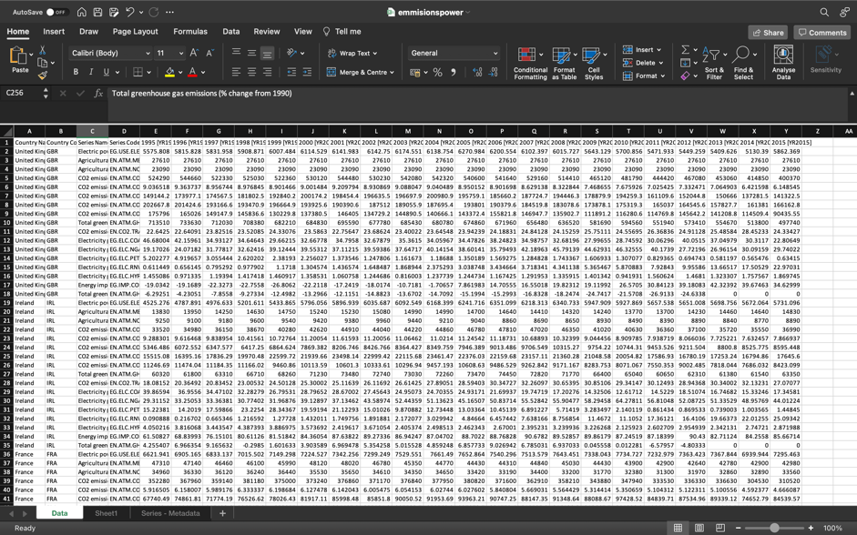

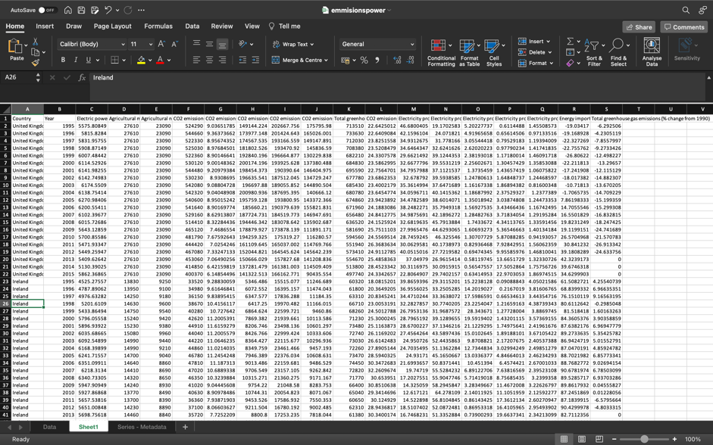

# Investigation of Data Workflows & Proposal for Design of Dashboard

The first attributes assessed was C02 emissions. The total annual C02 emissions for all the 15 countries were experimented on. For this attribute, the dimension, country, and continuous data, years, can be paired with the variable. The most appropriate presenting tool would be a time series line graph to compliment the time data. Therefore, a graph of C02 emissions over time in years can be seen for each of the respective countries chosen. The change in the total emissions from 1995 to 2015 can be seen and compared. This was completed by putting years data on the column aera and C02 emissions data on the row area in Tableau.

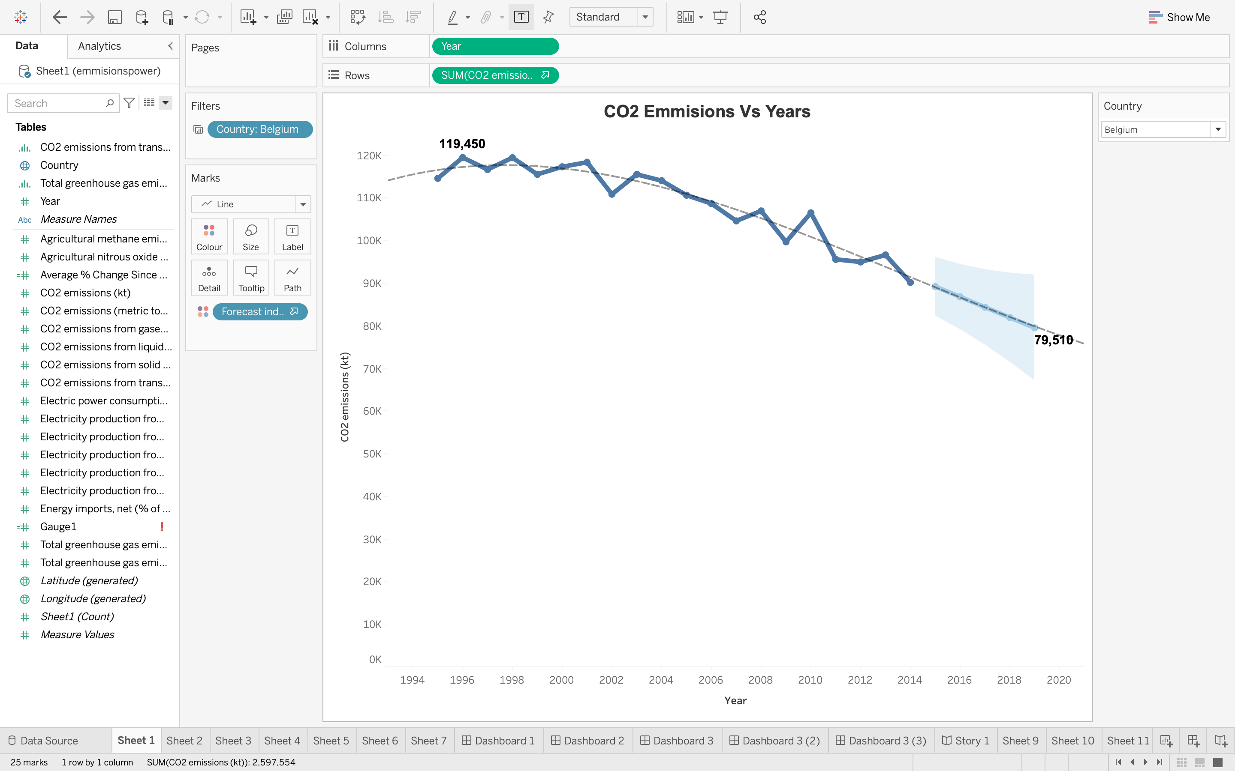

Furthermore, countries against one another can be compared to see how they perform however, for this dashboard, the whole dashboard will be cantered around the selection of one country from the list of 15. Additionally, forecast analytics can added to the times series graph to create prediction for how the emission will be in the next few years. Forecast analytics enhances the graph and brings a new perspective to how the countries are performing, do the countries need to do more or are they looking on track? To develop the generic time series graph further with its forecast data for the next 5 years, colour is added. People recognize, identify, and remember images better when the images are coloured (GeckoBoard, 2020). Colour is added to differentiate the between the forecast line and the line created from the imported data. In Tableau, this colour difference is created by dragging the forecast indicator dimension to the colour mark. This creates a clear separation between the estimated and actual data creating a Gestalt similarity principle. The 95% confidence interval created around the forecast points also creates an enclosure seen in the enclosure principle (TopCoder, 2019). These two principles create a clear divide. In addition to the implementation of these principles, the graph is cleaned to reduce clutter by removing grid lines and the trend line thickness is increased. Lastly labels to the min and max point are added and a polynomial trend line of power 3 is added to give a quick visual description where the points are trending to. The resulting sheet is,

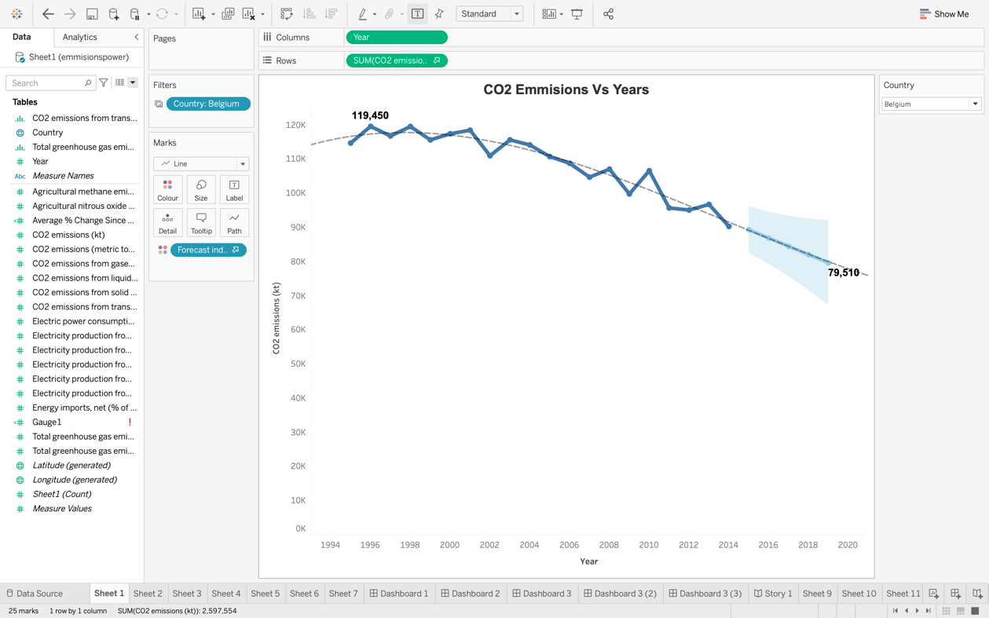

Next a similar line graph for the percentage of energy production created from renewable sources vs years is created using the same techniques as sheet 1. This similar graph was chosen due to the similar continues data. Like sheet 1, the time data, years, is added to the column aera and energy production data is added to the row aera. The only difference between this sheet and the previous is an action is created so, the same country is analysed that is selected from sheet 1. If Belgium on sheet 1 is selected, then a graph of Belgium’s percentage of energy production from renewable sources over time will also be created on sheet 2. This action was created by applying the filter on selected worksheets in the action tab under dashboard. Another Gestalt principle that is used in this plot is the connection principle between the points. People perceive things that are connected as the same group therefore the disconnection between the actual data and the estimate is a good separation (TopCoder, 2019). The following created sheet is,

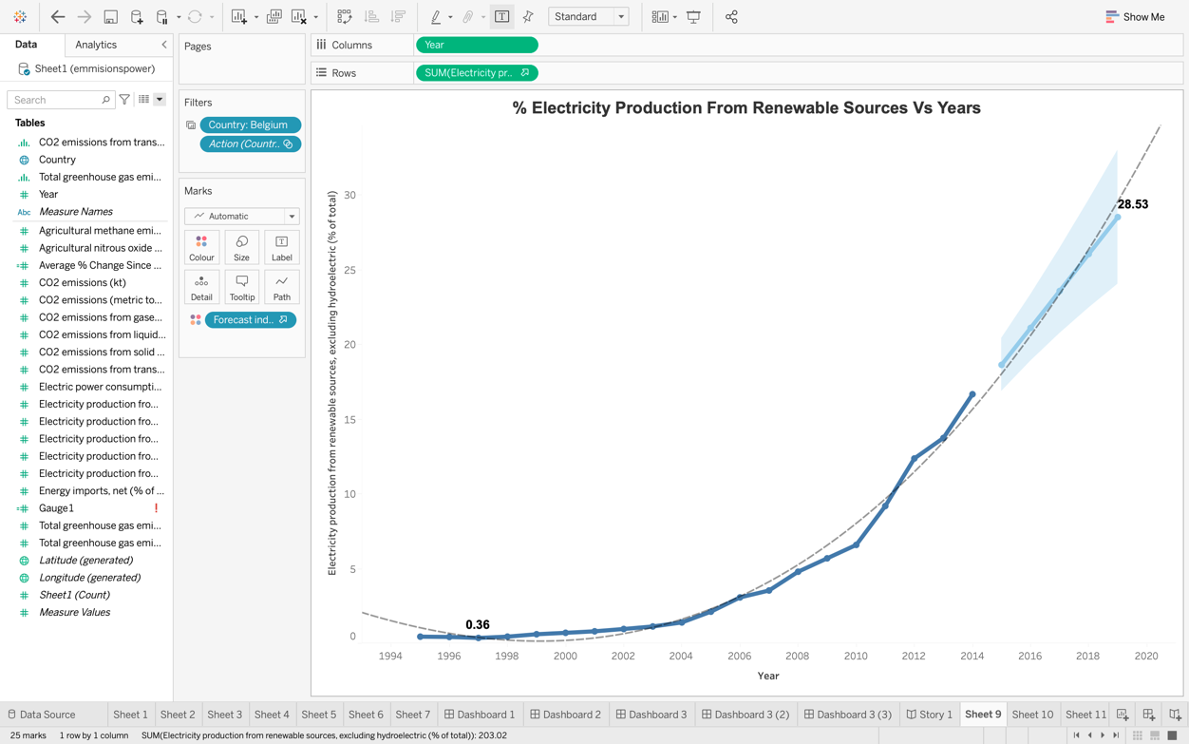

The next plot created is a graphically plot. This plot highlights the country that is selected from the action created previous. In Tableau, this plot is completed by having the longitude and latitude data of the chosen countries which Tableau will create automatically depending on the country name imported. For example, if the United Kingdom is selected, the respective country will be highlighted on a map. Furthermore, this creates and enclosure which emphasises the country. This is great for focusing the user and making them clearly aware what country the data is describing. In addition, total greenhouse gas data is paired to this graphically map. This is performed by dragging the greenhouse data to the colour mark. Therefore, the colour of the highlighted country will also demonstrate the amount of greenhouse gases that the country has produced. The darker the colour, the more greenhouse gases that country has produced. A label is also added to the map to indicate what country is selected. As a result, this graphical plot will allow the user will quickly understand what country the dashboard is describing.

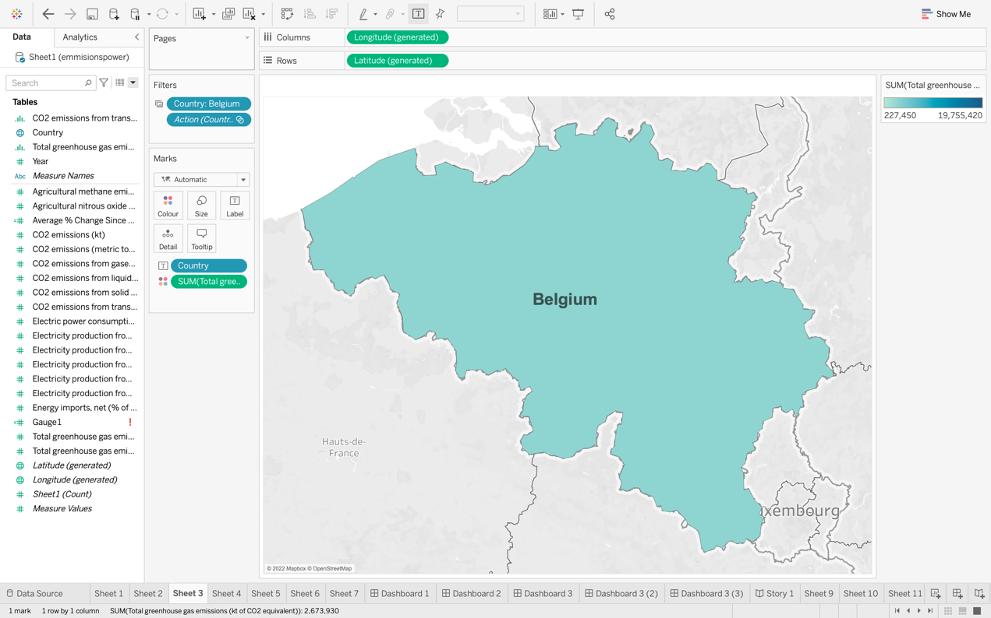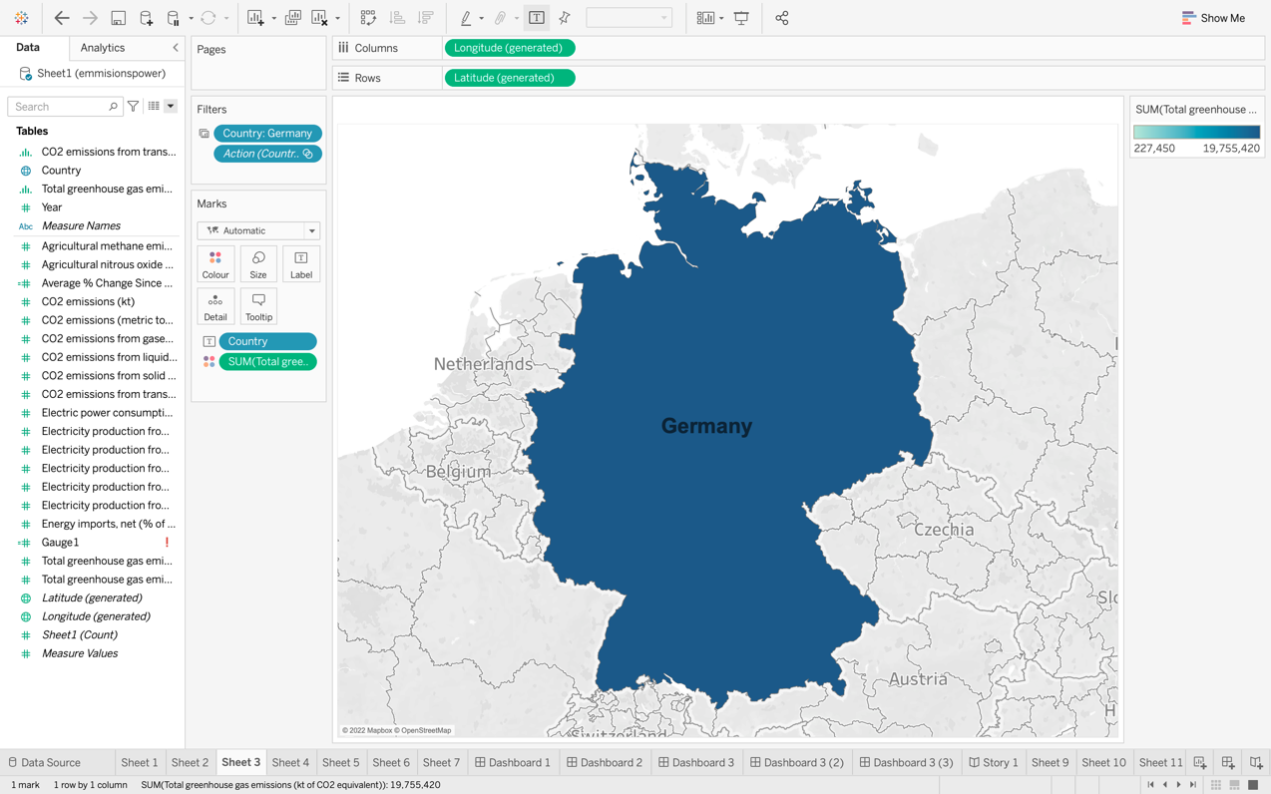

Additional to the single highlighted country, a whole graphical map of all the countries in the data can be analysed. Maps present geographic trends in a style that is familiar to everyone. Maps are a simple and engaging way to display how location connects with patterns in your data if you have geographic information linked with your data (Upasana, 2021). In this map plot, greenhouse gases are paired with the use of colour. Like the previous figures, the darker the colour, the more greenhouse gases that country creates. Labels are manually moved to avoid them overlapping and to make them more clear.

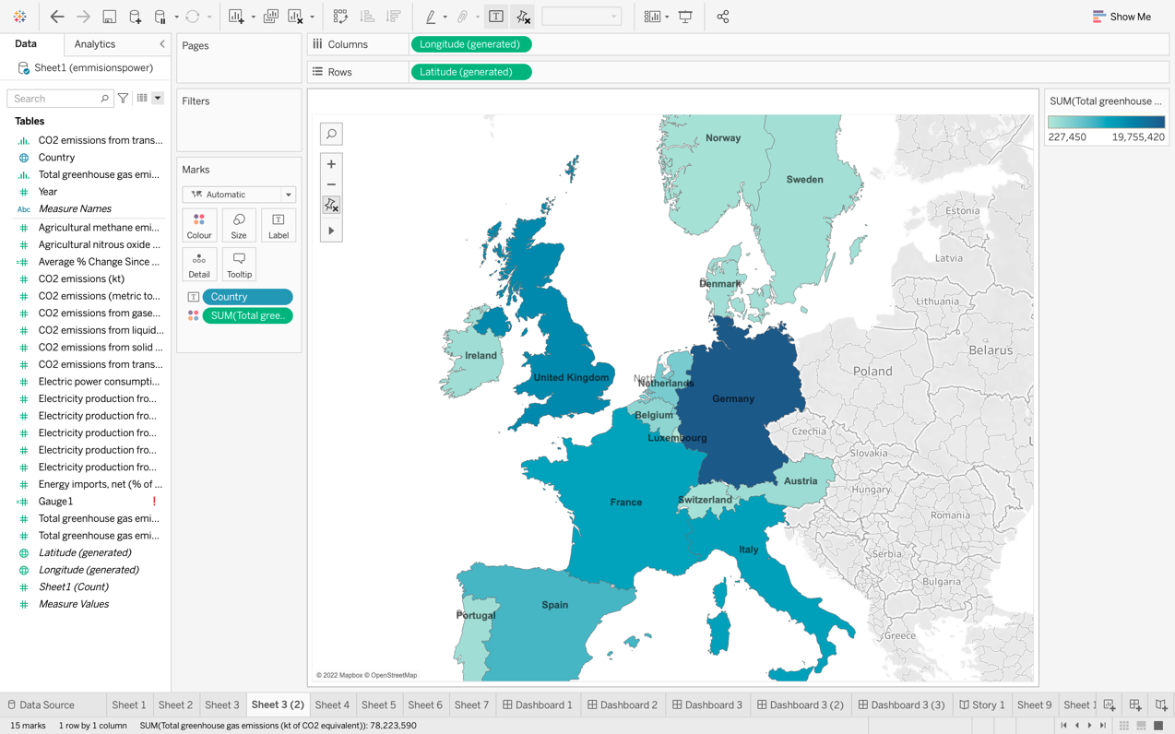

The next attribute that was to be explored was the sources of the C02 emissions. These attributes were explored by using a Bar chart plot. Briefly, you can quickly distinguish between categories, spot trends and outliers, and see highs and lows in the data. Bar charts are simple but effective, especially when your data is split into several groups (Upasana, 2021). Due to the several groups of sources of C02 emissions, the bar chart was chosen to analyse the data. The data variables that are used in this bar chart for comparison are C02 emissions from oil, coal, and gas but also the total greenhouse gases for that respective country chosen. The greenhouse gas attribute can be included into this plot since the attribute is measured the same as the other categories, C02 equivalent. Furthermore, for this plot, the bar is ordered in ascending order so the user can easily distinguish what category is higher than the other. This is a feature of Gestalts principles called continuity. The eyes follow a continuous path in the chart on the right below, which makes the entire chart more readable due to the constant downward orientation (Craig, n.d.). Also, colour is added to this graph like the figure described previous. Colour helps the user differentiate the bars into separate groups.

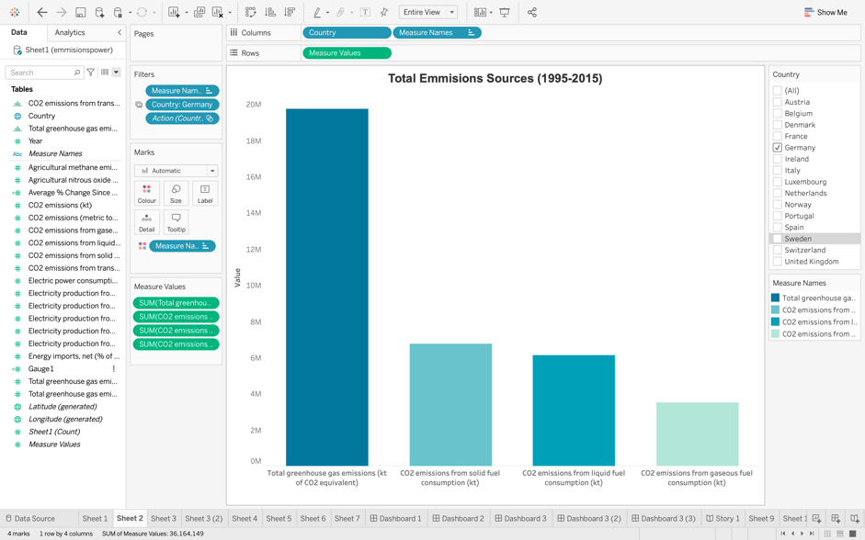

The average change in greenhouse gases since 1990 is explored across all countries. This was completed by creating a calculated field. Calculated fields allow you to create new data from data that already exists in your data source (Tableau, 2021). The original data source is the percentage change in greenhouse gases since 1990 and new data is created by taking the average for all countries. Using this new data source, a bar chart is created for the new average parentage greenhouse gas change since 1990 for all the countries. Furthermore, like the previous bar chart, similar techniques are used including the continuity principle and colour. However, in this plot, labels are added to the minimum and maximum bar. These added labels help the user understand quickly and easily how the best and worst countries are performing.

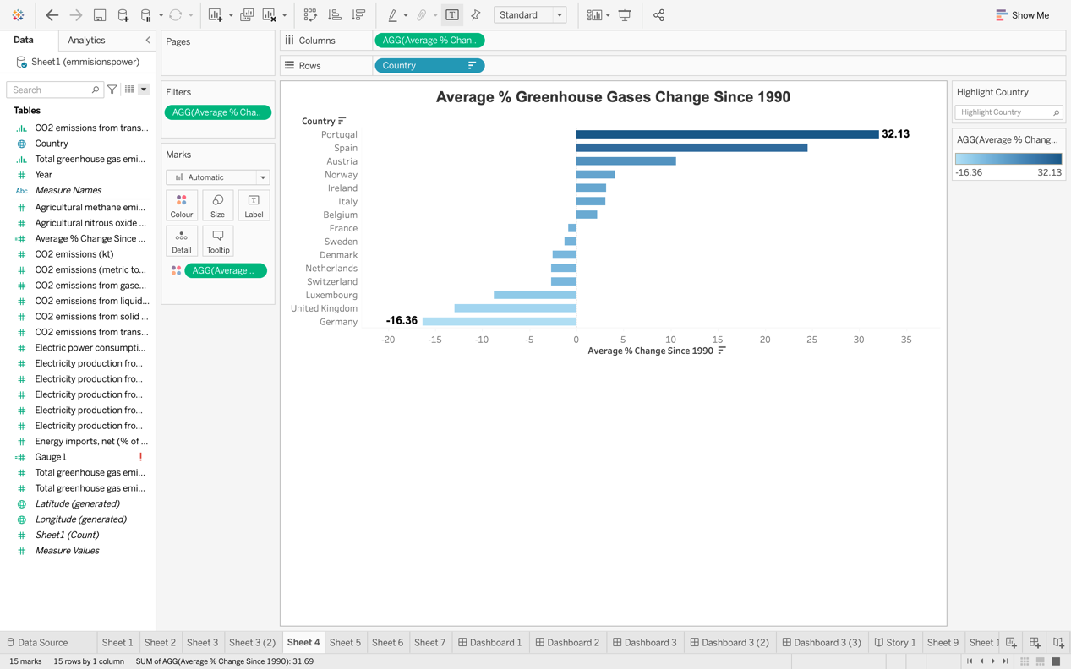

Additionally, to the time series line graph for one country, all the countries can be used in one graph. This graph was created by creating a filter by country and creating a division of the country by colour in the “marks” tab. This process will include all the countries onto one plot and separate them by colour. This creates a line series graph for easy comparison of the total C02 emissions over years.

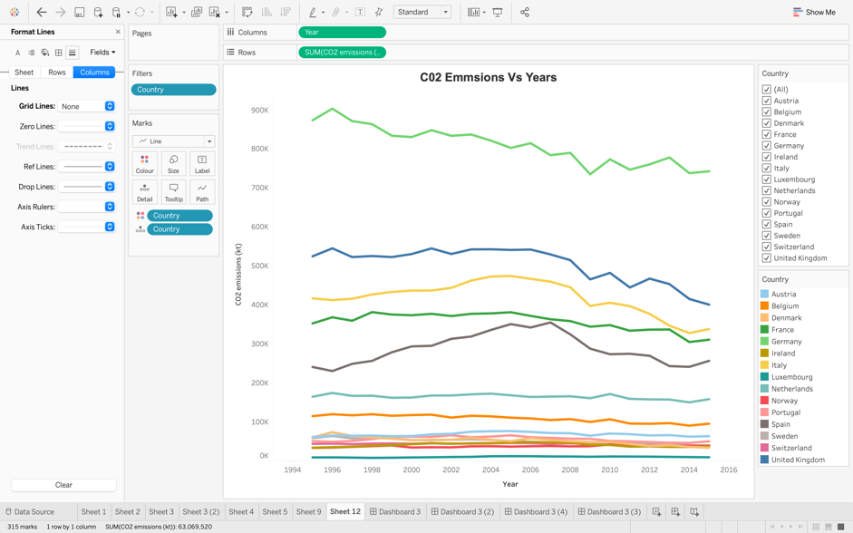

Lastly using all these described sheets, a dashboard can be created. For this dashboard, the overview of a particular country will be targeted with some comparisons. This dashboard will focus and highlight a particular country that is selected by the user. The dashboard will include figures giving an overview of the emissions and renewable power use of each country. The resulting dashboard is,

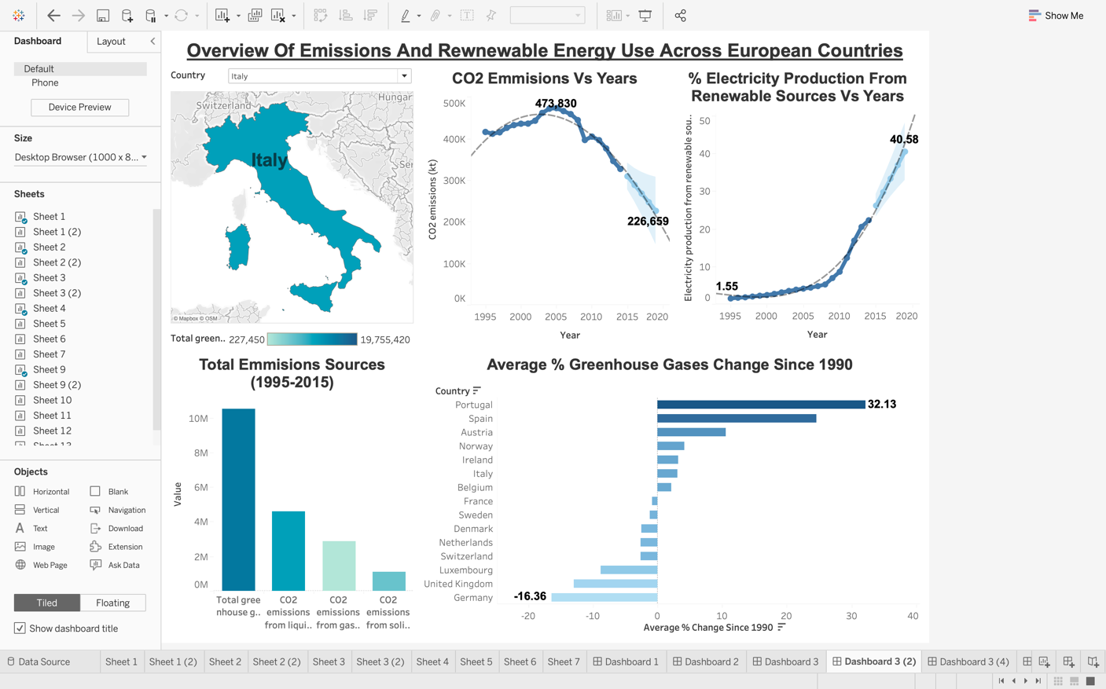

# Discussion

The dashboard contains the 5 figures mentioned before with all having a consistent style and colour. Titles and labels of all figures use a bold black arial font and all figures use a consistent blue toned colour. The luminosity in the colour in all figures are kept consistent, a bigger value would result in a darker colour and vice vera. This means, it is easier for the user to understand the values behind the plots when exploring in depth or quickly glancing. The figures are laid out in a z pattern as a Z-Pattern design traces the route the human eye travels when they read — left to right, top to bottom (Mialki, 2021). Therefore, the figures are laid out in a way to compensate for this and create a more informative story. First a country is chosen from the action filter at the top left of the dashboard. This filter will change all figure except the comparison figure bottom right. For example, like the figure above if Italy is chosen, location, emissions and renewable energy data will all be used for the respective figures. Next the map plot will highlight the country that is selecting giving the user extra reinforcement in knowing what country they are exploring. The two-line plots adjacent to the map plot are paired together since it is interesting to see how C02 emissions change dependent on how the use of renewable power. Next, the bottom left bar plot, is used to expand on the emissions trend and breakdown how that country is creating the C02. Lastly, the bottom right plot is used to compare the average change in greenhouse gases and gives a good conclusion to the dashboard. For this Dashboard, the initial proposal was to explore how the emissions are affected by the use of renewable energy for electricity production. The dashboard does an effective job at comparing both these variable with the two adjacent time series graphs for the respective years. In this dashboard, many data visualization techniques and principles have been used which all have been explained above.

For all countries there is a general negative trend for C02 emissions per year and positive trend in the amount of renewable use per year. Taking Italy as an example seen in the dashboard figure, there is a decrease in the C02 emissions as there is at the same time, an increase in the renewable energy use for electricity production. Giving an indication that with an increase in renewable energy sources results in a decrease in emissions. Using the forecast analytics, by 2020 the amount of C02 emissions would have decreased to 226659 Kt compared to the 473830 Kt in 2005 which is over double. Italy is predicted to see a decrease in C02 emissions of 52.2% in just 15 years. This is huge. This decrease is not realistic as a plateau would be expected however it is a good sign. During this period, the percentage of renewable sources for electricity production would have increased from 4.17% to 40.58% in the year of 2020. This is an increase of almost 10 times. Out of solid, liquid, and gaseous fuel use for electricity production, most of Italy C02 emissions comes from liquid fuel like oil and least from solid fuel like coal. Furthermore, seen from the bottom right plot, Portugal has seen the greatest increase in greenhouse gas creation compared to 1990 and Germany has seen the biggest decrease.

# Conclusions

To conclude, in this paper, a dashboard was created using Tableau on 15 European countries to oversee the forms of electricity used and the emissions these countries are making. This Dashboard was created to look at the trends and trajectories these countries are heading to quickly know what countries needed to act. The dashboard provides two time series graphs on the C02 emissions and Renewable energy use, a graphical map of the location observing paired with greenhouse gas data and finally bar chart to look at the breakdown of the total emissions and the percentage change of these emissions since 1990. These 5 figures give an effective overview of the status of these countries and is easily readable due to the data visualization techniques used and seen in this paper.

# Part Two: Statistical Analysis

# Background Research

The phrase "correlation analysis" emphasizes the relationship or association between two variables. It assesses the magnitude and direction of a relationship between variables (Gogtay & Thatte, 2017). A positive pho value would indicate a positive correlation, a negative pho value would indicate a negative correlation and when the pho is equal to zero, no correlation. A Pearson’s correlation coefficient is used when the data is known to be normally distributed otherwise a spearman’s correlation is used instead. Due to unknown normality, a Spearman’s correlation will be used in this report.

dynamic conditional-correlation model was performed on 9 Asian daily stock return data from the years 1990 to 2003 and it was found that during a crisis period there were two phases of the correlation coefficient. One phase included an increase in correlation and the other, a shift in variance. Furthermore, it was found that During the Asian financial crisis, a dynamic correlation study suggests that there was evidence of contagion effects (C.Chiang, Nam Jeon, & Li, 2007).

The link between electromyographic activity of various laryngeal muscles, subglottal air pressure, and the fundamental frequency of vibration of the vocal folds has been developed. Using correlation analysis, the findings indicate that this type of research can give a useful measure of correlation between physiological and acoustical events in speech (E. Atkinson, 1978).

A technique for extracting common features from a pair of multivariate data is canonical correlation analysis. However, because of its linearity, it does not extract important information in challenging circumstances. The kernel method employed in support vector machines is an effective way to improve such a linear method (Akaho, 2007). Kernel Canonical Correlation Analysis has been demonstrated to be a strong method for finding patterns between two complex perspectives of data, though these patterns may be overly flexible if not properly regularised (Hardoon & Shawe-Taylor, 2009).

In addition, Regression analysis is a statistical method for determining the relationship between two or more variables. In most cases, the investigator is trying to figure out what causes one variable to affect another. in this report, an investigation between the total emissions and the percentage use of renewable energy for electricity production (Sykes, 1993). Regression analysis uses a mean squared error to evaluate this dependence and aims to predict Y variable based on the observation X variable. a popular method used for regression analysis between two variables is referred to as the linear model (Falk, Marohn, & Tewes, 1995).

Forestecosystems in China were studied using a regression model based on the geographically weighted regression (GWR) method, which considers spatial non-stationarity in the parameters estimated. The GWR method predicted NPP significantly better in simulations than the OLS (ordinary least squares regression) method, as evidenced by the corrected Akaike Information Criterion and R squared value. The model performance of GWR was significantly better than that of OLS and the spatial lag model (Wang, Ni, & Tenhunen, 2005).

The accuracy of the predictions made by the computational models used in process control systems must be assessed on a regular basis for efficient operation. Linear regression is proposed as a tool for distinguishing systematic and random prediction errors from measurement-related errors. Rolling force calculations are subjected to linear regression analysis. The regression-based assessment procedure was discovered to be capable of being carried out automatically for set periods of time. This enables model calculations to be corrected and the controlled equipment's performance to be improved (Poliak, Shim, Kim, & Choo, 1998).

The banking and finance industry has become increasingly competitive as a result of globalisation and technological advancement. The accuracy of managerial decisions has a significant impact on the industry's performance. In order to predict bank performance, this study employs a multiple linear regression technique and a feed forward artificial neural network. The study looked at data from thirteen banks from 2001 to 2006. When using real data, the linear regression has some limitations because its underlying assumptions are always violated. The presence of outliers causes parameter estimators to be biased. Linear regression is compared to an artificial neural network in this paper, and it is discovered that the neural network is more powerful (Bakar & Tahir, 2009).

A statistical method in which an analyst verifies a hypothesis regarding a population parameter is known as hypothesis testing. The type of the data and the objective of the study influence the analyst's methodology. Hypothesis testing is the use of sample data to determine the plausibility of a hypothesis. (MAJASKI, 2021). The process of hypothesis testing is to specify the Null Hypothesis, specify the Alternative Hypothesis, set the significance level (a), calculate the test statistic and corresponding P-Value, and draw a conclusion. There are multiple types of hypothesis tests including Anova, Z test, F Test, Chi squared test and the T-test.

# Exploration of Data Set

The dataset used is the same dataset used in section 1. This dataset was chosen to explore the emissions and electricity production across 15 European countries from the years 1995 to 2015. All missing data was rectified in section 1. This data preparation step consisted of removing certain countries that had little to no data and removing years that had little to no data. Furthermore, filling in cells that had no data with the mean across that row. Finally, transposing the data into a format readable for Tableau used in the previous section and SAS in this section. This was all done in excel and the dataset was imported into SAS. This importation was completed by going to File>New>Data and then selecting the dataset from the computer directory. Then the sheet that is imported is selected in the data import wizard outputting it into a SAS formatted table in the process flow section. There are 18 variables used.

Years: Years used from 1995 to 2015

Country: The 15 countries that was used in the dataset.

Electric Power Consumption: The Electrical power consumption from such places like power plants.

Agricultural Methane Emissions: Animals, animal excrement, rice production, and agricultural waste burning all contribute to agricultural methane emissions

Agricultural Nitrous Oxide Emissions: Agricultural nitrous oxide emissions include those caused by the application of fertiliser, the management of animal waste, and the burning of agricultural waste.

C02 Emissions: Carbon dioxide emissions are those caused by the combustion of fossil fuels. Carbon dioxide created through the combustion of solid, liquid, and gas fuels is among them per person.

C02 Emissions from Gaseous, Liquid and Solid Fuel: Carbon dioxide emissions from liquid fuel, Gaseous and Solid fuel consumption.

Total Greenhouse Gas Emissions: Total greenhouse gas emissions in kt of CO2 equivalent.

C02 Emissions from Transport: CO2 emissions from transportation include emissions from all modes of transportation's fuel burning.

Electricity Production from Coal, Natural Gases, Oil, Hydroelectric Sources and Renewable Sources: Sources of electricity refer to the inputs used to generate electricity

Energy Imports: Net energy imports. Negative value means the country exports energy. More than it imports.

Total Greenhouse Gas Emission Change since 1990: Each year's data provides the percentage change in total greenhouse emissions from 1990 to that year.

# Preparation of the of Data Set In SAS:

Firstly, the program, SAS enterprise guide is opened on the desktop computer where we can create a new project. To create a new project, on the programs tool bar, under File>New>Project. Once this step is completed, a new process flow is created where all the programs and processes like importation of the data can be viewed. Next, importing the data by going to File>Import Data and following the step in the import data wizard. The wizard will first ask for the location and which worksheet in Excel you would like to use if there are multiple. Select the correct sheet and press next where a view of the data will be displayed, select which rows are required and press next then finish. The data selected for this assignment was the data prepared in Excel in the previous part.

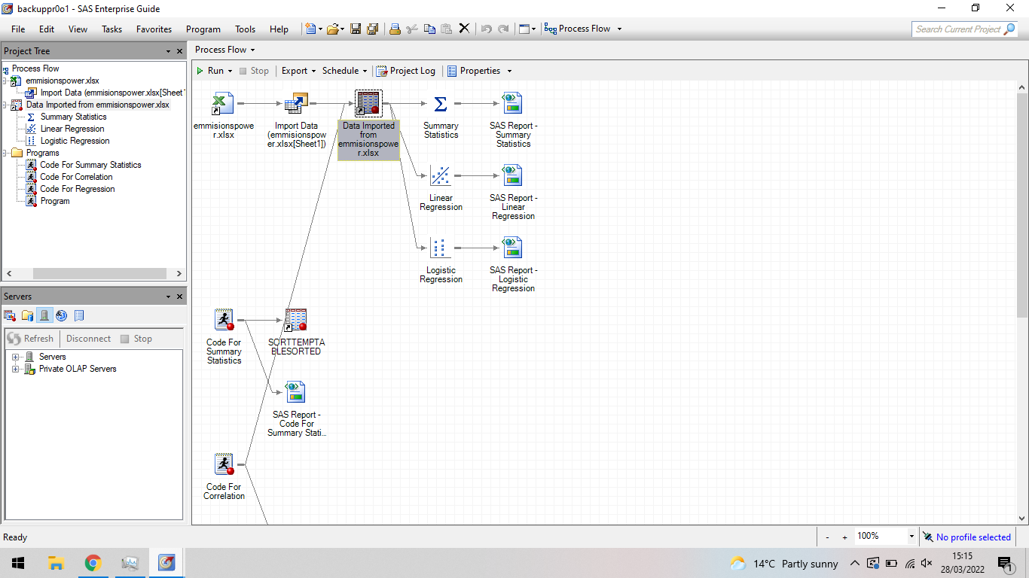

# 4-1

In this part, the objective was to complete a comprehensive descriptive statistical analysis on the data which included the mean, mode, median, standard deviation, skewness and kurtosis. The objective was completed by making a program in SAS by going to File>New>Program. A following blank program will appear where code can be written. The following code is written to complete this objective,

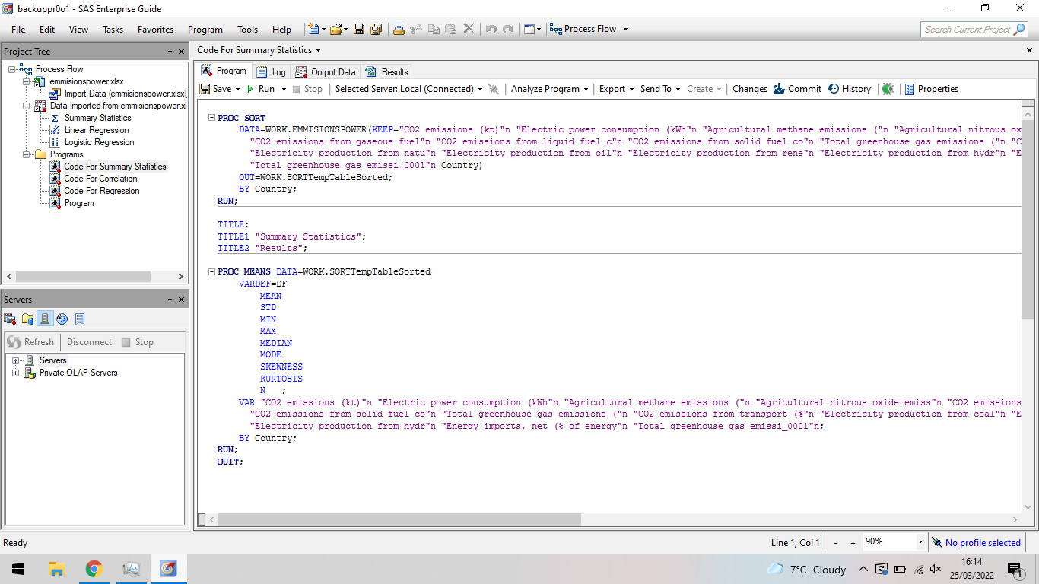

The first part of the code sorts the data by countries to avoid an error later down the line when calculated the Means and separating them by the 15 countries used. After this, Titles are added and next the means are calculated. For this code, first the global command PROC is used which essentially calls and starts the procedure which is means. After this, the data and statistical parameters that are going to be calculated are chosen. Lastly, the means are then completed on Variables chosen and segregated by country. The comprehensive descriptive statistical analysis on the data that is produces is as follows,

Austria:

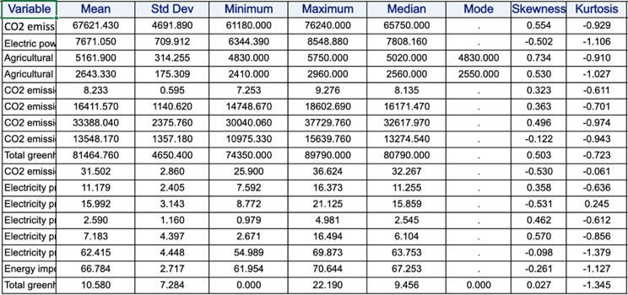

Belgium:

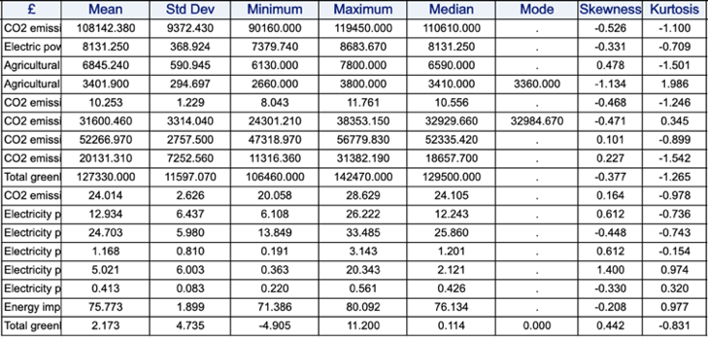

Denmark:

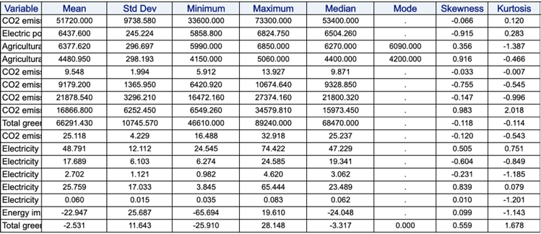

France:

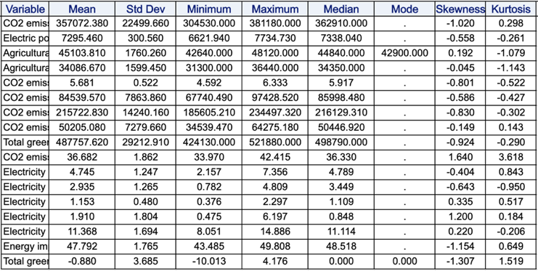

Ireland:

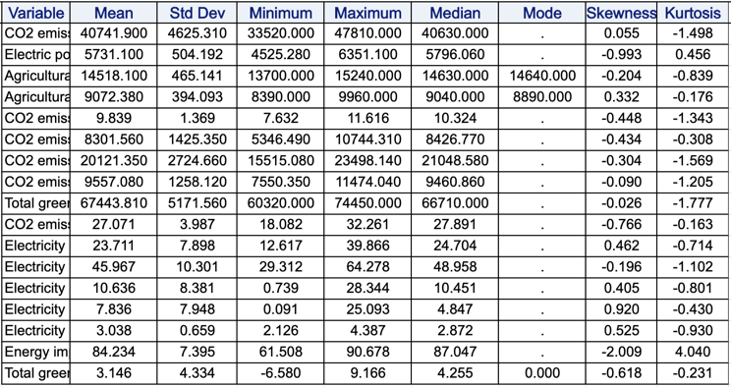

Italy:

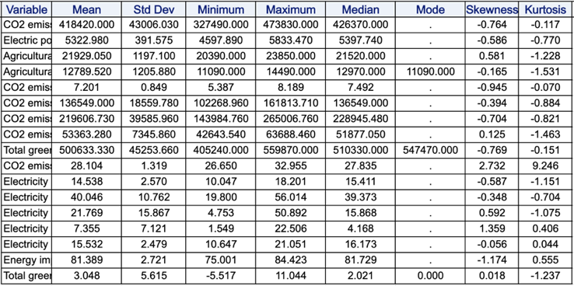

Luxembourg:

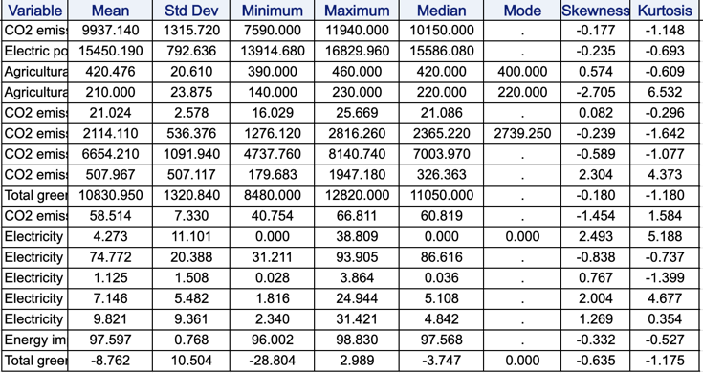

Netherlands:

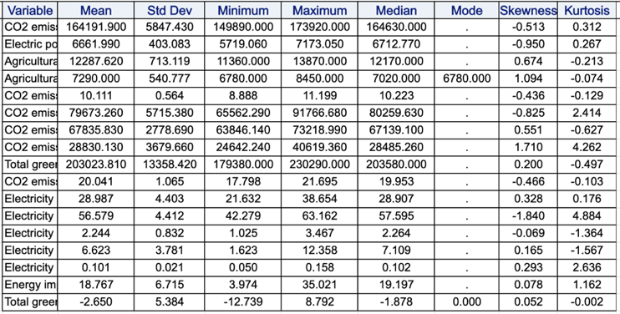

Norway:

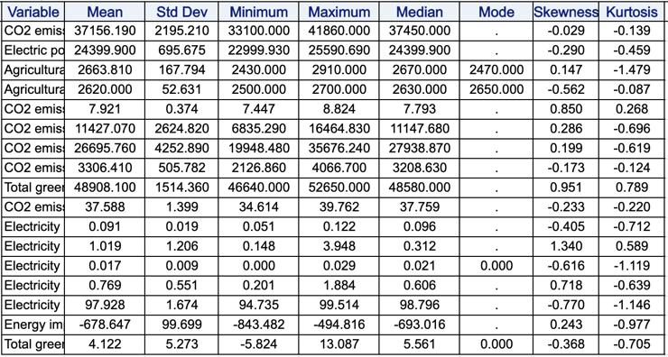

Portugal:

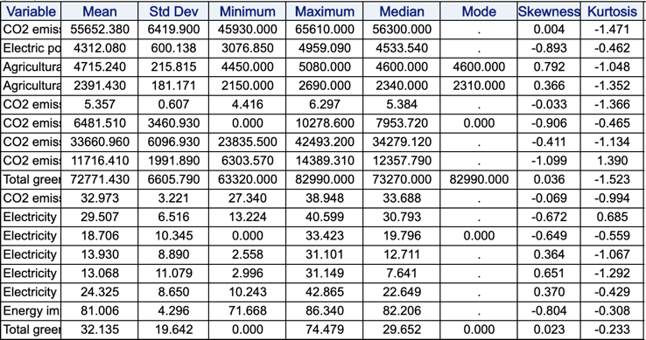

Spain:

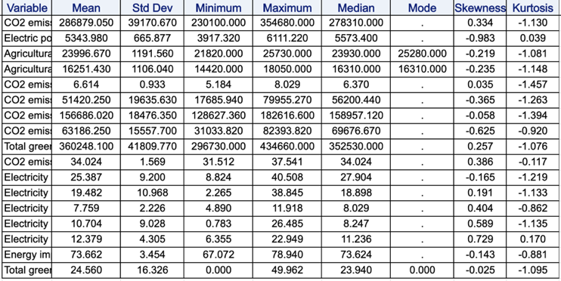

Sweden:

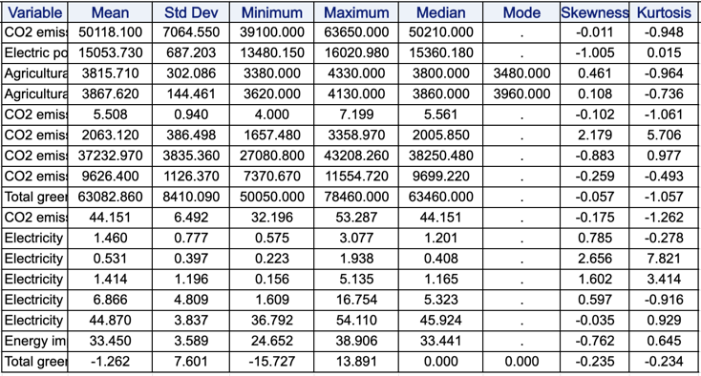

Switzerland:

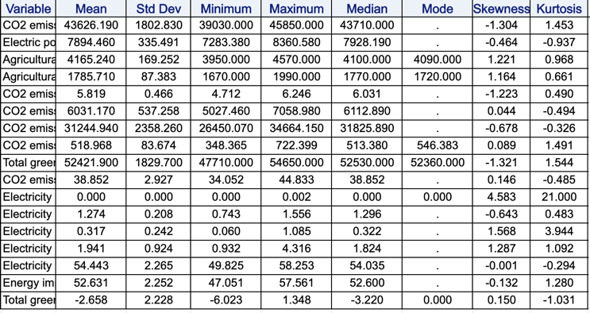

United Kingdom:

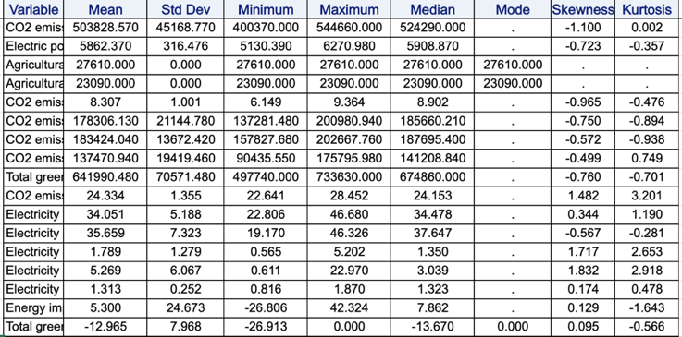

Germany:

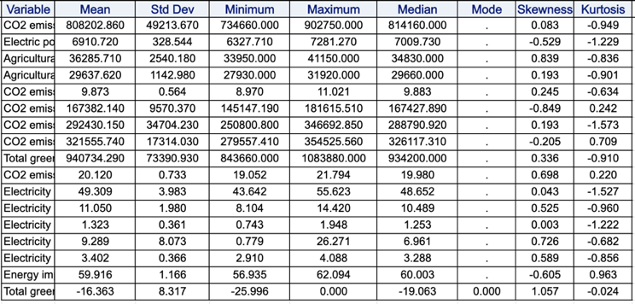

# 4-1 Discussion

For part 4-1, a comprehensive statistical analysis of all the variables across the 15 countries was completed. The analysis consisted of gathering the mean, standard deviation, minimum/maximum, median, mode, skewness and finally kurtosis.

Mean and Median:

The mean is a measure of the centre of the data and where the data lies. The mean is an average of the data. Median like mean is a measure of where the centre of the data lies however the median is the middle number of the data. In this analysis, the mean and median are calculated for each variable of each country over the period of 1995 to 2015. Both the median and mean produce the same or similar values across all variable and countries. It can be seen from the figures above, that Germany produces on average the most C02 emissions and Luxembourg the least. Germany creates a massive 808202 Kt of C02 per year on average since 1995 to 2015 whereas Luxembourg creates a tiny 9937 Kt. This massive difference is most likely due to the difference in size and production of the two countries however Germany’s amount is scary. Comparing Germany to a similar superpower in the Europe, the United Kingdom, on average Germany still created a massive 37.7% more C02 gas. It is interesting that Germany is also a big importer of electricity, importing 59% of their used power since 1995 on average. Indicating that even with the massive emissions, it could be much more if they produced all their own electricity. On the other hand, Germany is going in the correct direction in becoming greener as they had an average change of greenhouse gases of -16.4% since 1990. Additionally, Germany has the biggest decrease since 1990 and Portugal have the greatest increase. Portugal greenhouse gases have increased by 32.1% since 1990. On average the biggest producer of renewable energy is the country Denmark having 25.8% of its electricity produced by renewable sources. Denmark also exports the most electricity.

Mode:

Mode is a measure of the most frequent values. The mode can be useful in some analyses, but it typically lacks enough precision to be useful in establishing the shape of a distribution. The Mode might be deceiving when it is not a normal distribution analysis.

Standard deviation:

Standard deviation is a measure of spread and give you information how spread the data is to the mean. Tell you how close the values are to the mean. For the data, the emission of C02 and greenhouse gases have large standard deviation for all countries indicating large fluctuations over the years. The emission is never the same and change massively every year. Furthermore, Spain and Portugal have large standard deviation for the change in the percentage greenhouse gases compared to 1990 value. Indicating a large spread of values and large fluctuation in the percentage change for these countries, there is no stable change.

Skewness and Kurtosis:

Skewness is a metric for the lack of symmetry.  If a distribution, or data set, looks the same to the left and right of the centre point, it is said to be symmetric. Kurtosis is a measure of how heavy-tailed or light-tailed the data are in comparison to a normal distribution. Looking at Germany for example, The C02 emission has small skewness indicating that this variable is normal distributed. Furthermore, the kurtosis is negative indicating a light tailed distribution. Therefore, for the C02 emissions variable, it is normal light tailed distributed. Lastly looking at the electricity produced by renewable energy, the skewness was 0.726 and Kurtosis of -0.856. As a result, this variable is skewed to the right and light tailed. skewed right means that the right tail is long relative to the left tail (Engineering Statistical Handbook, n.d.) (Engineering Statistical Handbook, n.d.).

# 4-2

For part 4-2 a correlation analysis on the variable for the countries has been completed for the objectives mentioned. The objective was to investigate how greenhouse gases correlate with renewable energy use. A correlation analysis for all 15 countries was performed on this question. The Correlation was completed using SAS by going to File>New>Program. A following blank program will appear where code can be written. The following code is written to complete this objective,

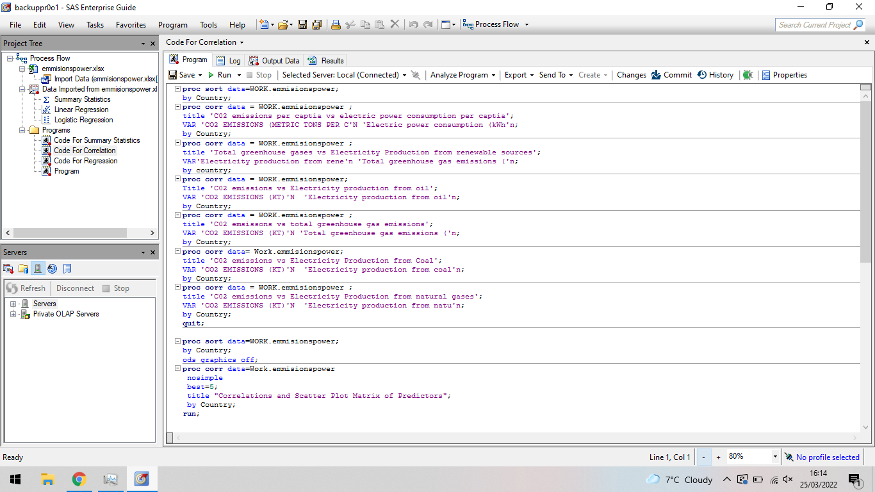

The First part of the code sorts the data by Countries. This was done to avoid a later error caused when the correlation is done for each country. Next a correlation analysis is performed using the CORR command, this command produces a correlation analysis between two variables. For example, the two-variable chosen for the first analysis are CO2 emissions and Electric power consumption.

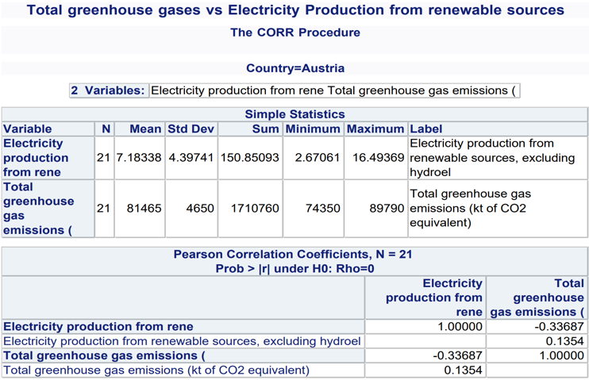

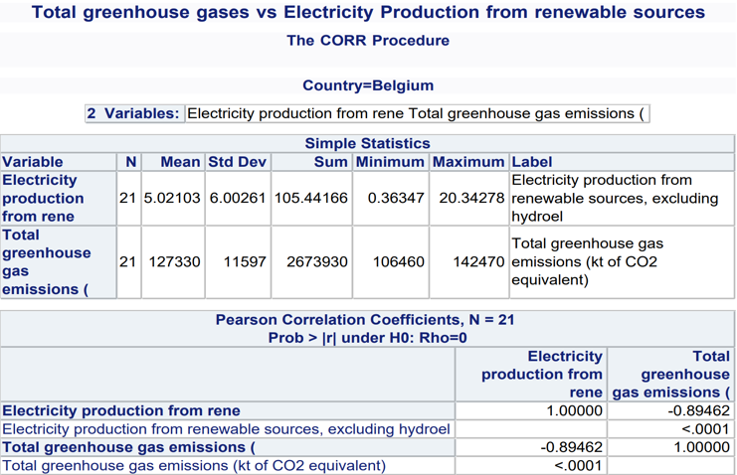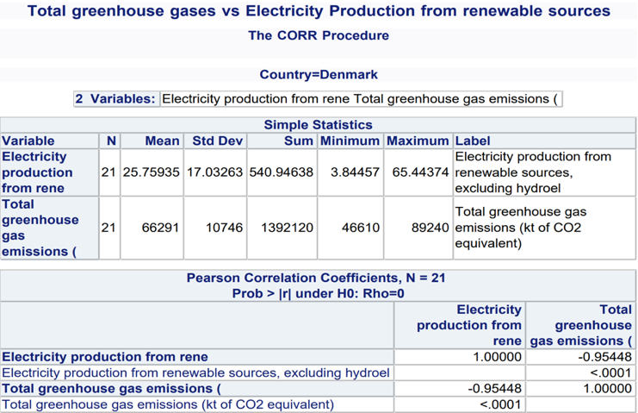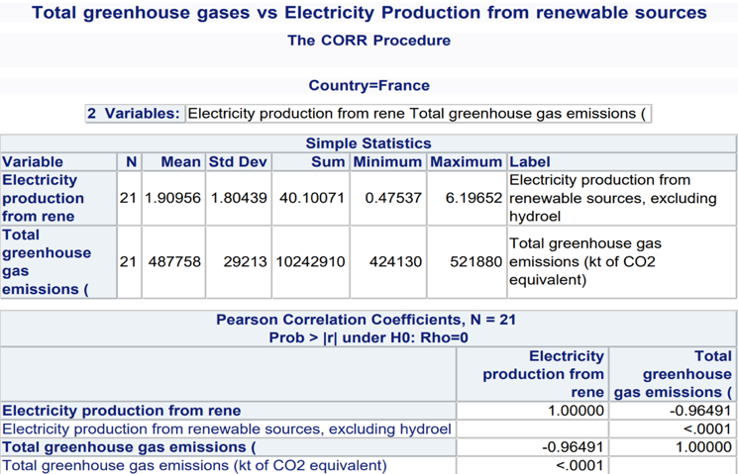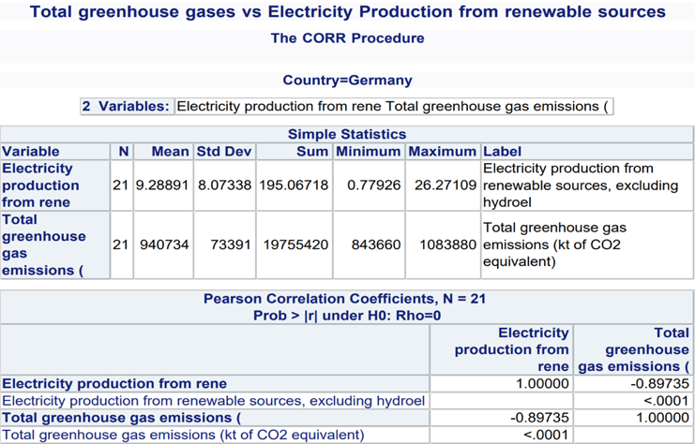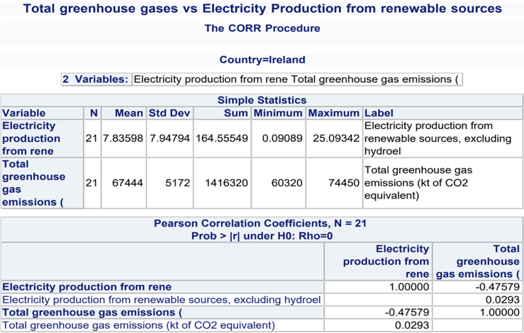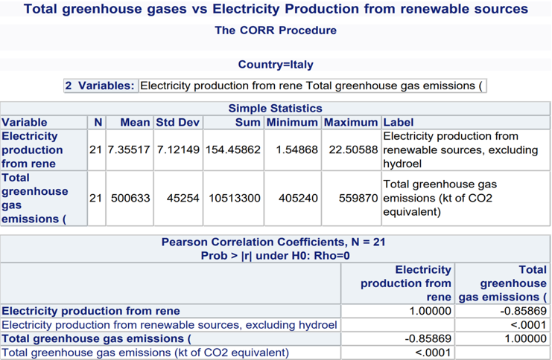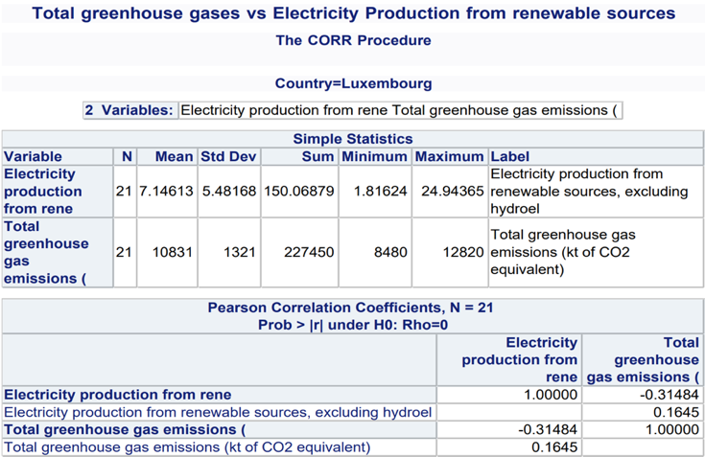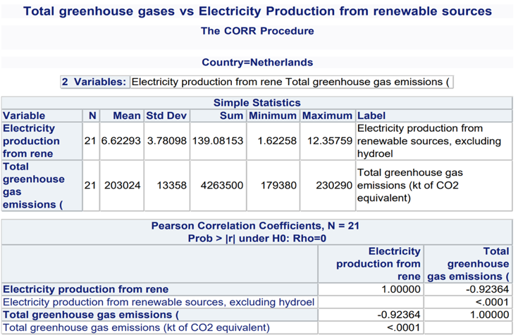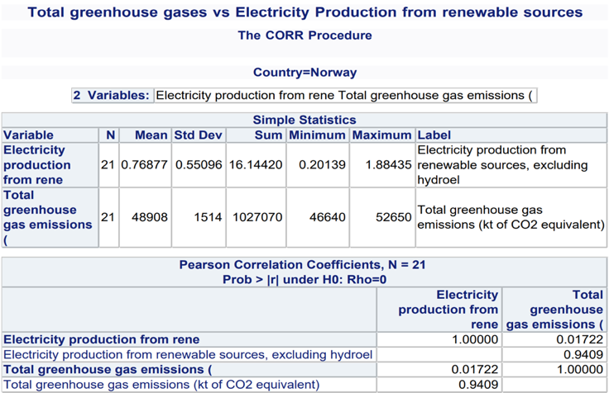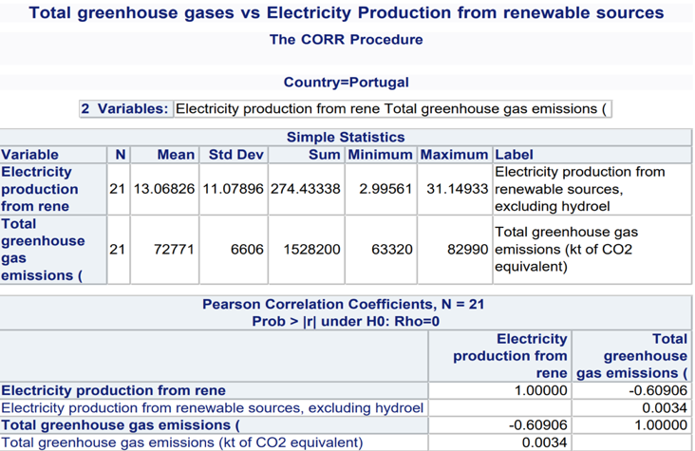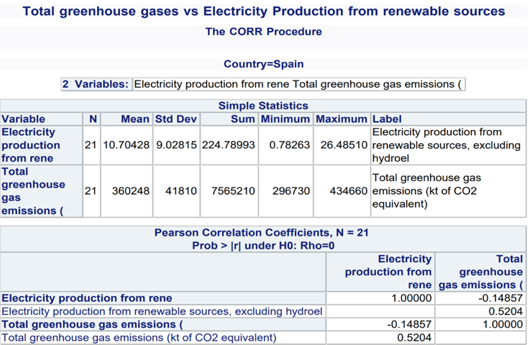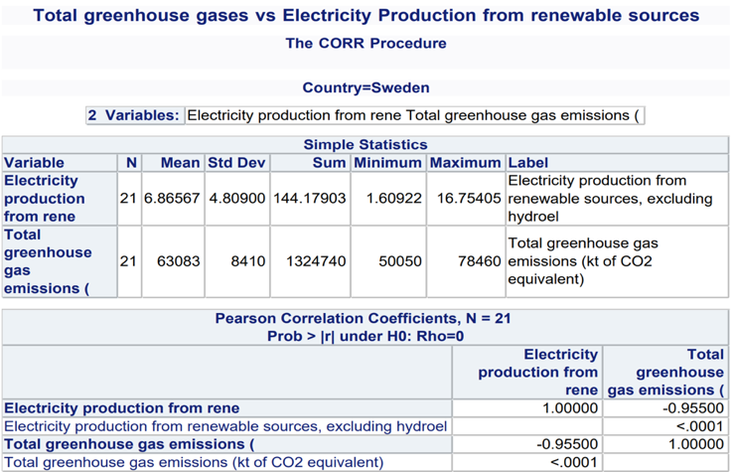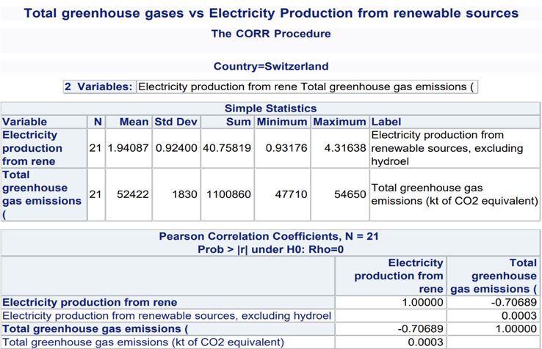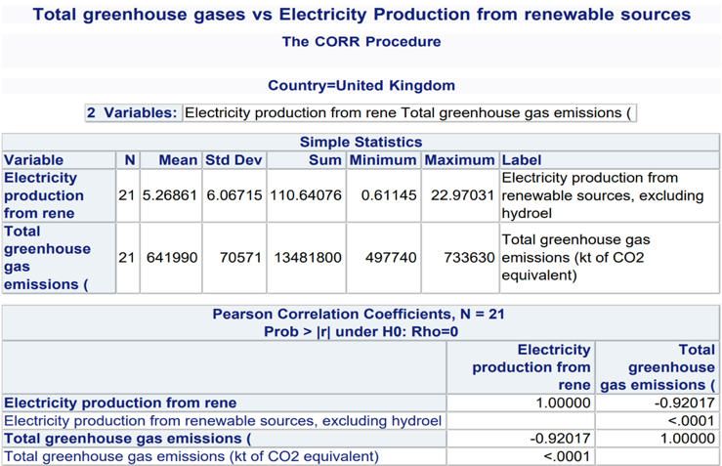

# 4-2 Discussion

Correlation is a statistical measure that expresses the extent that two variables are linearly related. In this objective, two variables are investigated for each country, total greenhouse gases and electricity production from renewable sources. For each of the countries data, the correlation is tested. As a hypothesis, the use of renewable sources would cause a negative correlation meaning as the use of renewable sources increase the greenhouses gases decrease. This negative is seen in all countries however, the correlation is more negative in some indicating that the renewable source variable has a stronger effect on the greenhouse gases. The more negative the value, the more the two variables linearly relate. The UK, Sweden, Netherlands, Italy, Germany, France, Denmark and Belgium all have very strong negative correlation. This also indicate that if these countries focus on using renewable sources for electricity creation, they could reduce their greenhouse gases emissions effectively. On the other hand, Countries like Norway and Spain have little to no correlation indicating, the two variables are not linearly related.

# 4-3

For this part, a regression analysis on the chosen data has completed. This task was completed using the program SAS. A regression analysis on the total greenhouse gases and percentage electricity production from renewable sources like the correlation analysis seen in part 4-2 is tested. by going to File>New>Program. A following blank program will appear where code can be written. The following code is written to complete this objective,

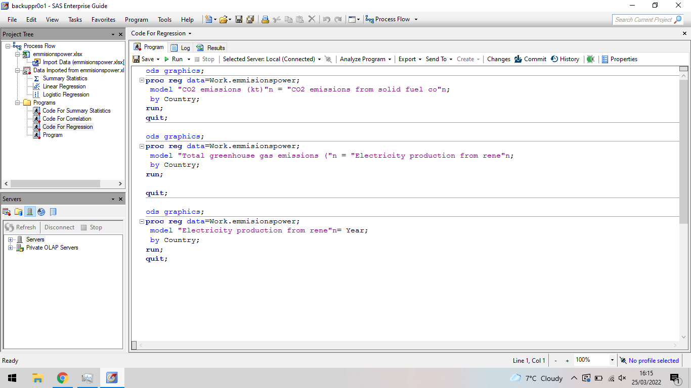

ODS graphics is a statistical procedure that produces integrated outputs that include graphs and tables needed for the regression analysis. After this, the regression analysis can be done using the function REG. However, a model must be established based of variables that wanted to be explore. The function MODEL allows for the correlation between the two selected variables. Lastly the regression is done by country like the other parts.

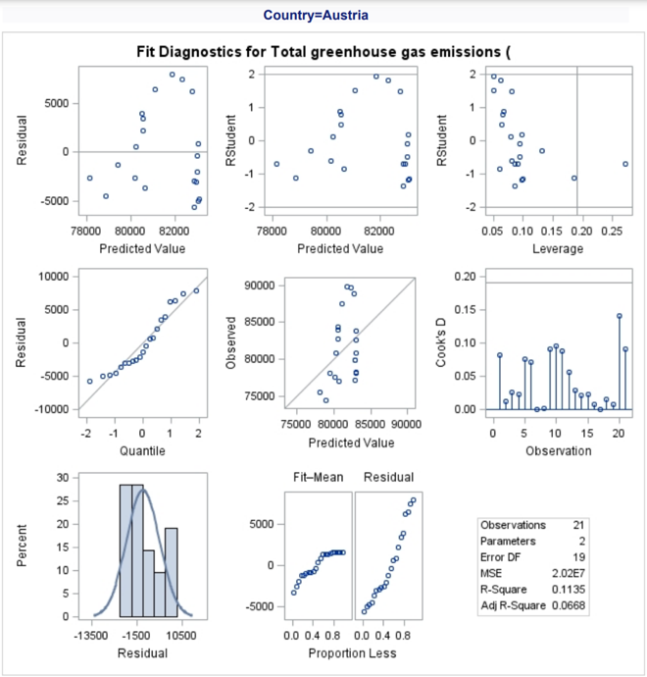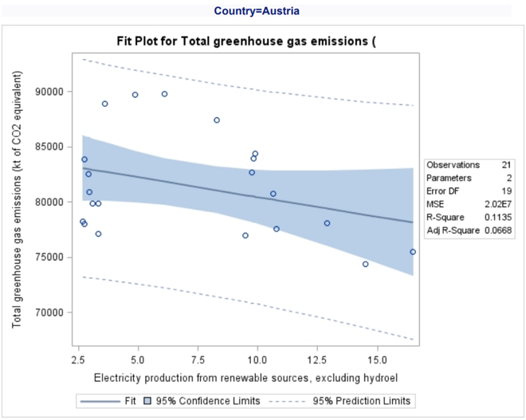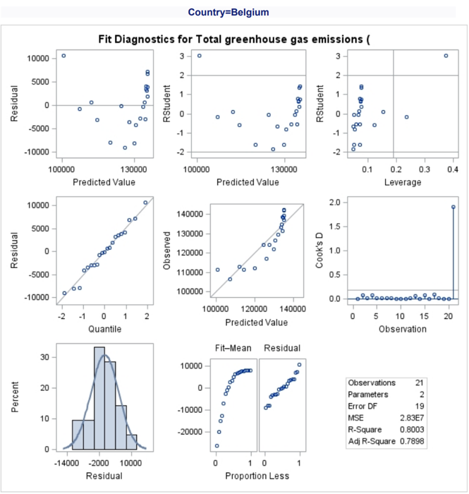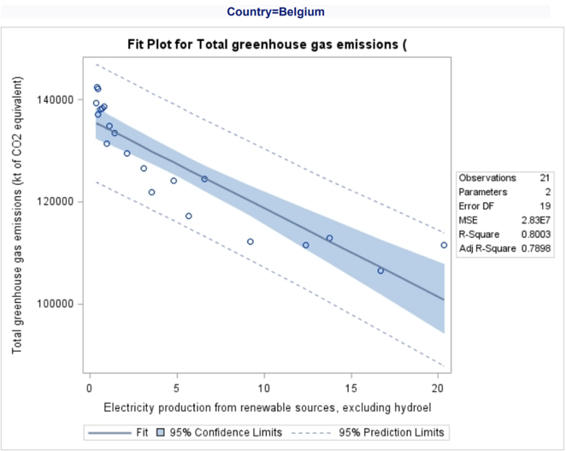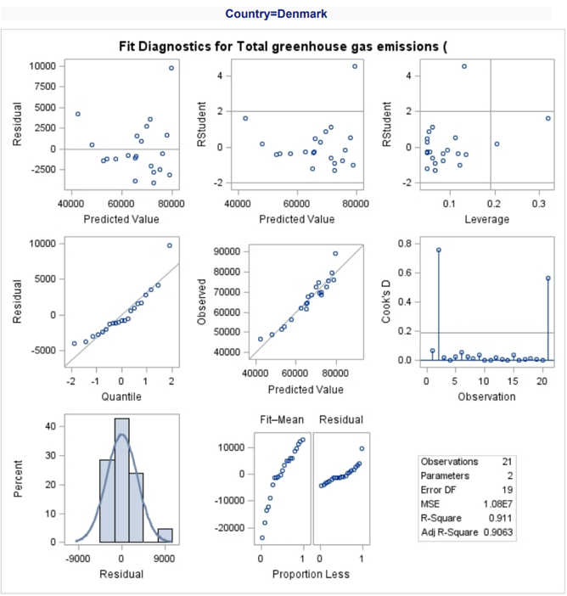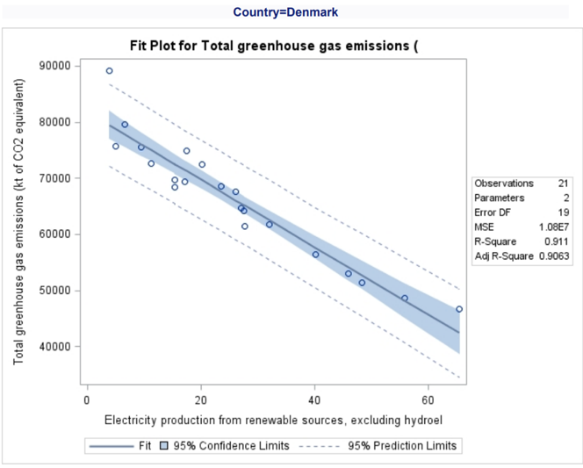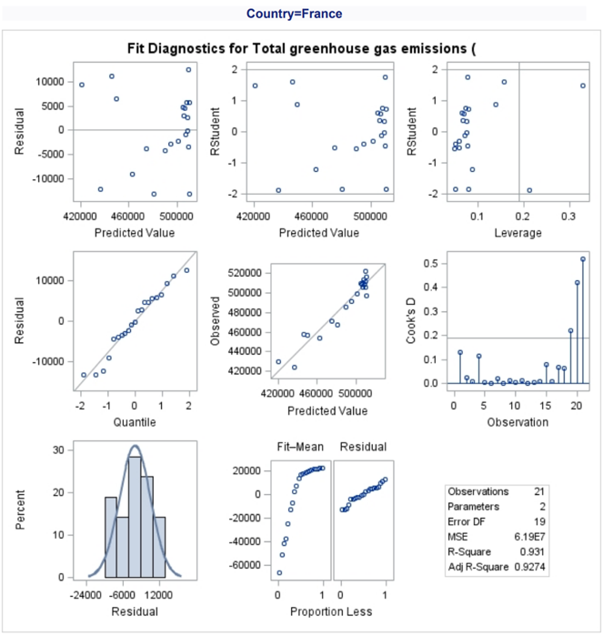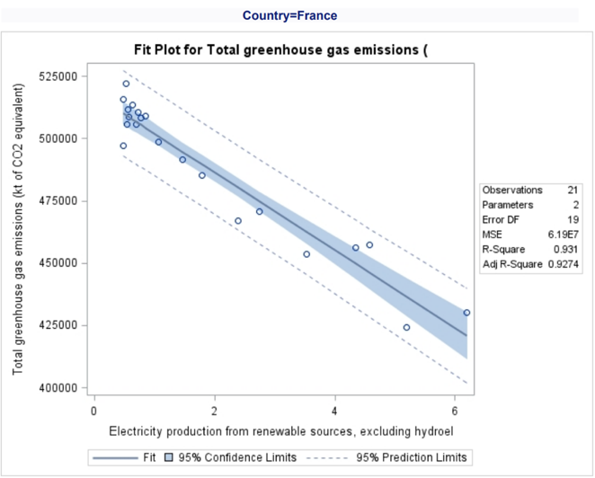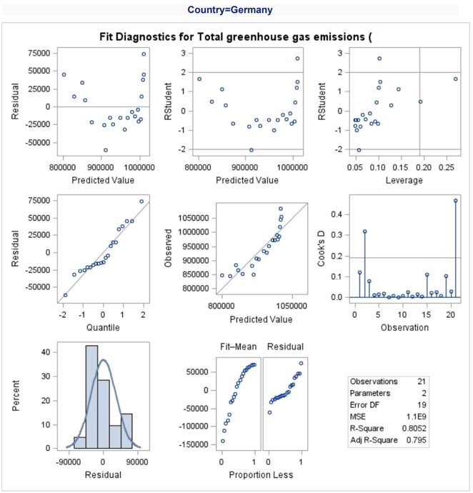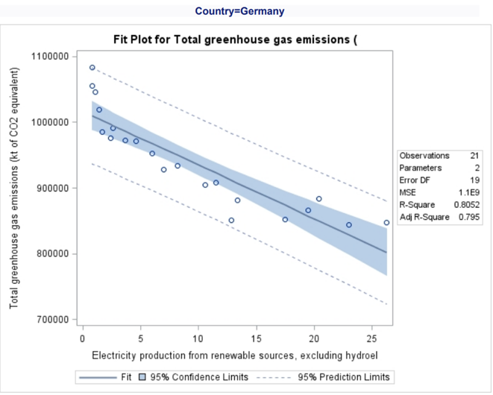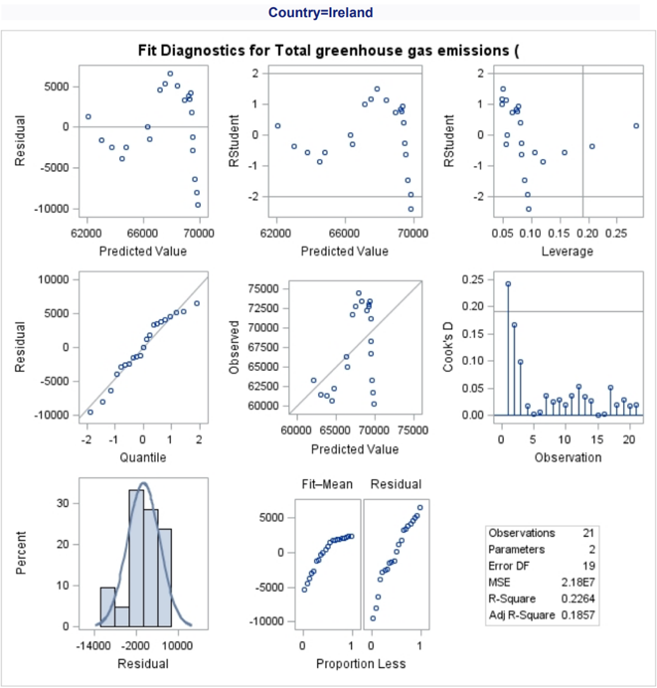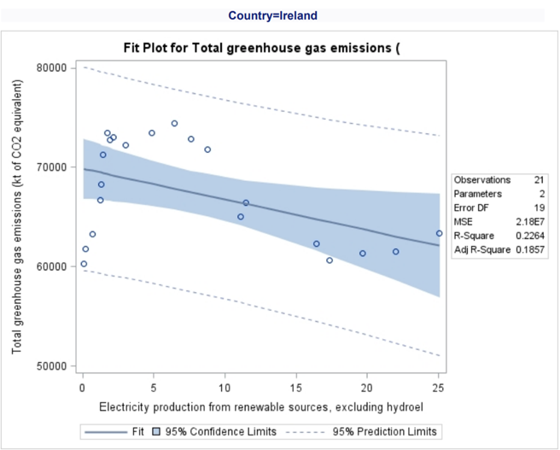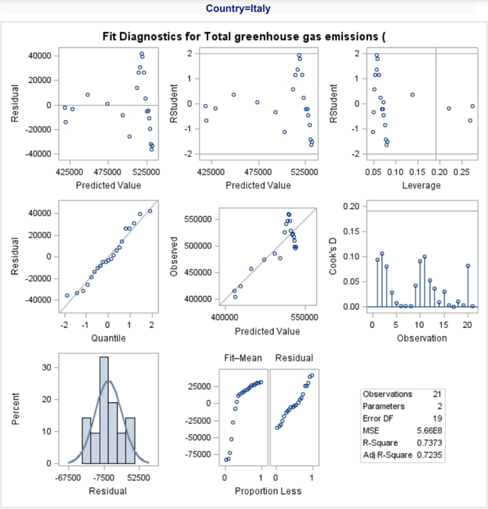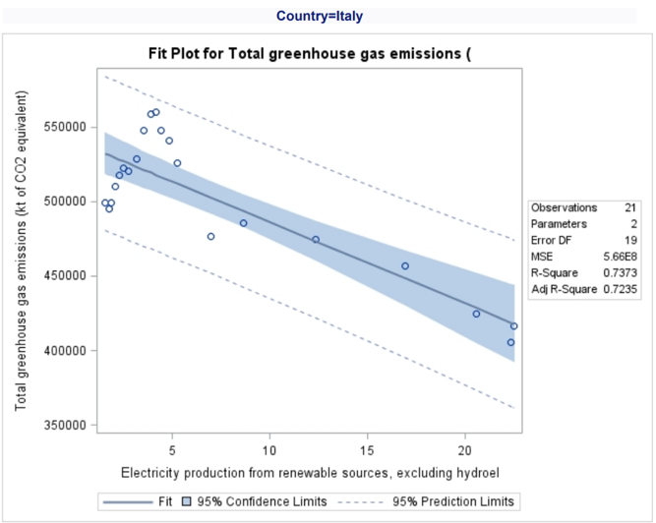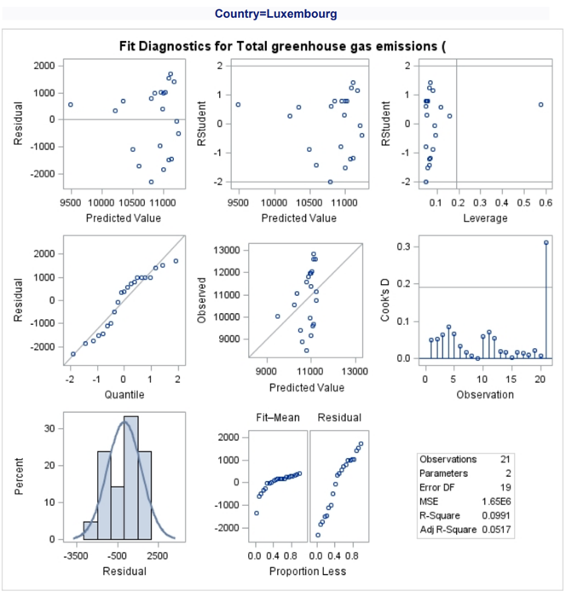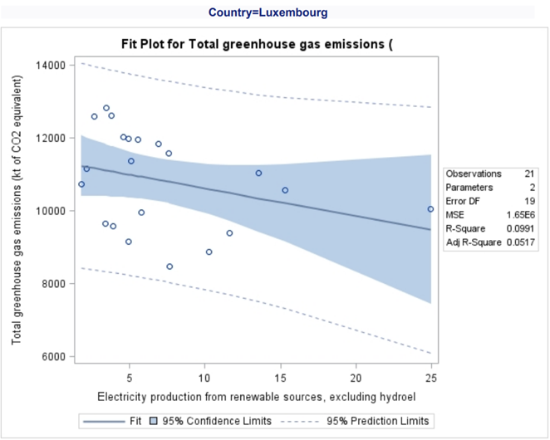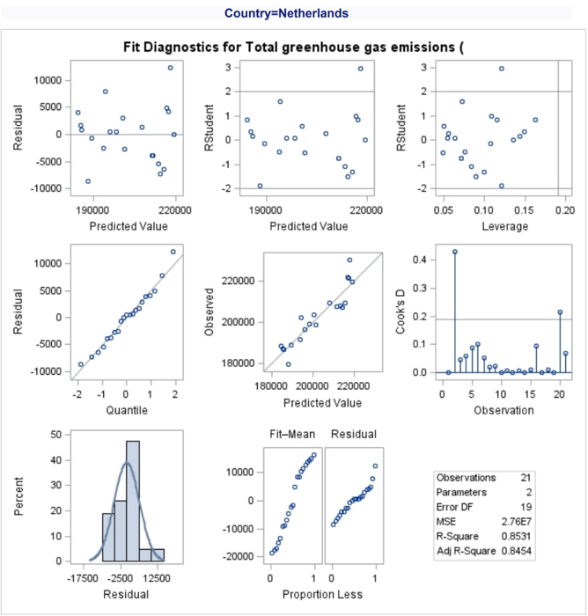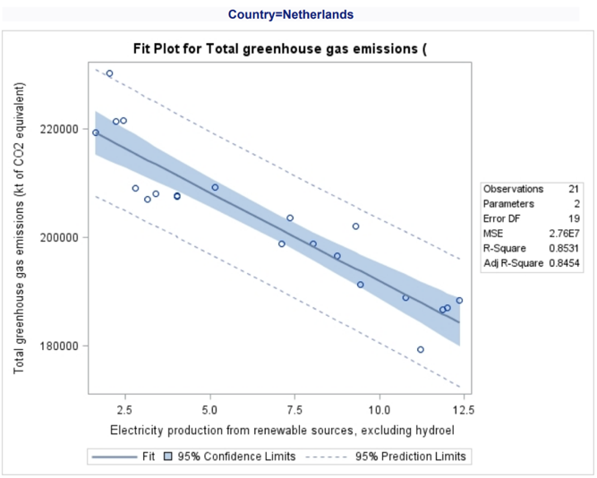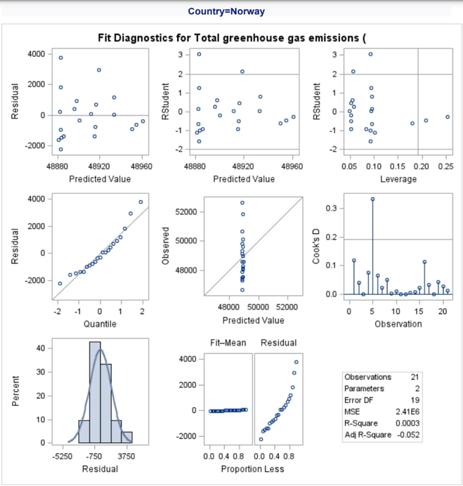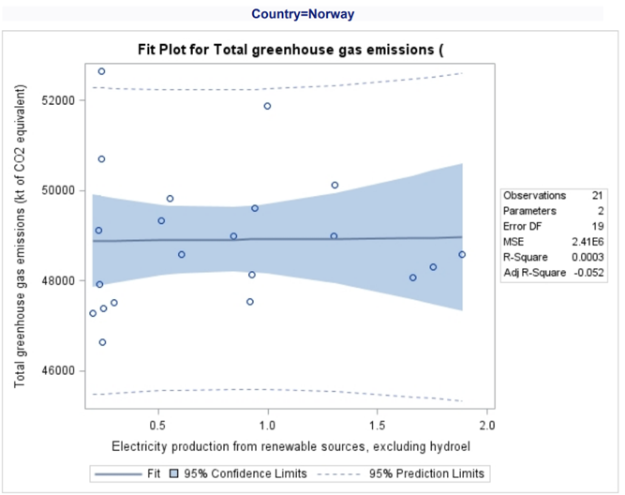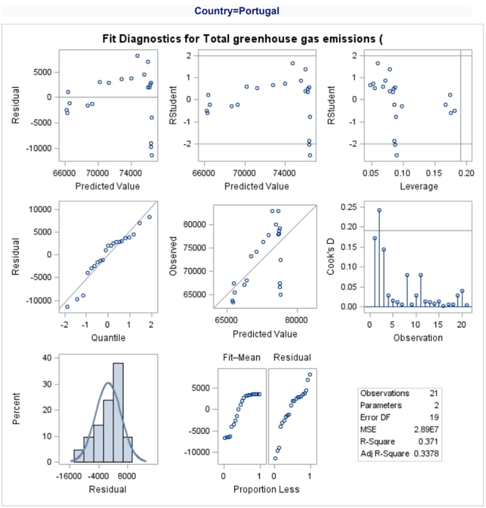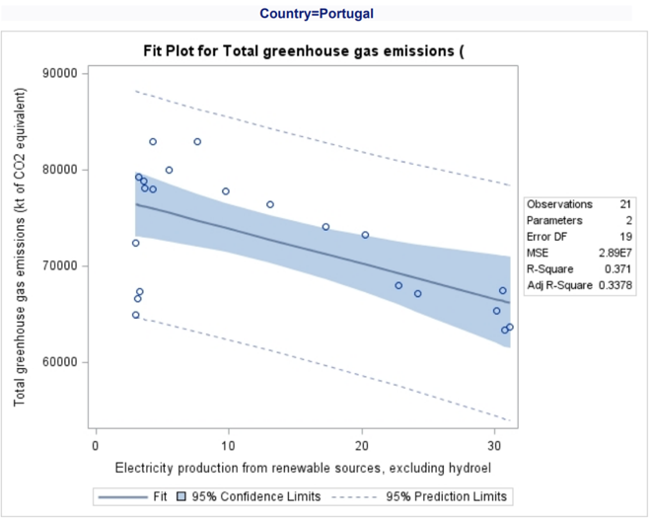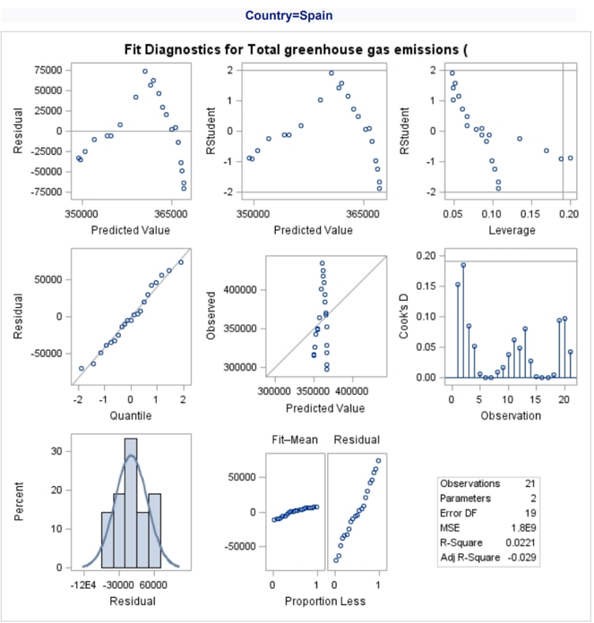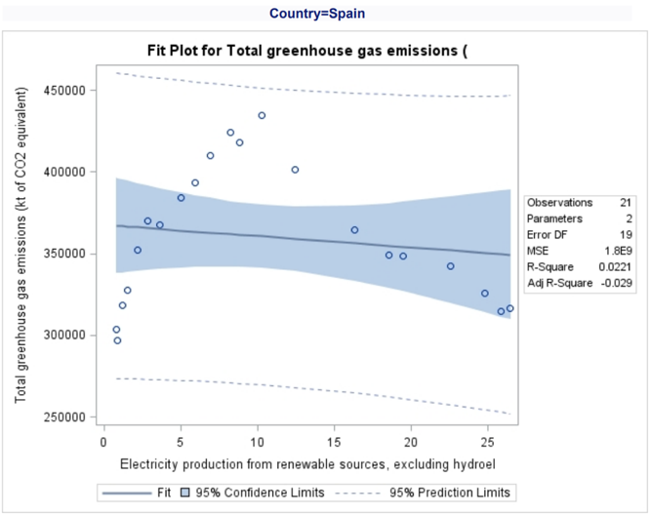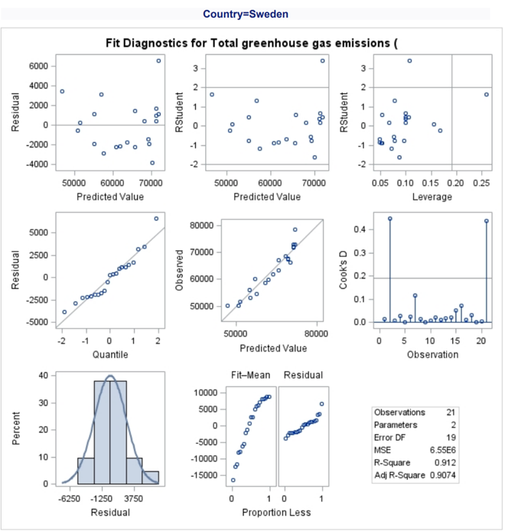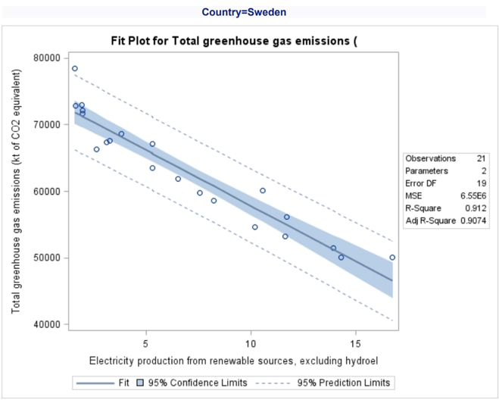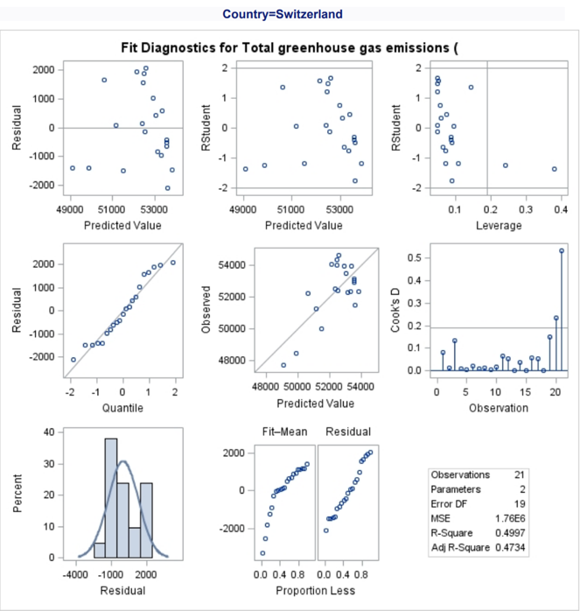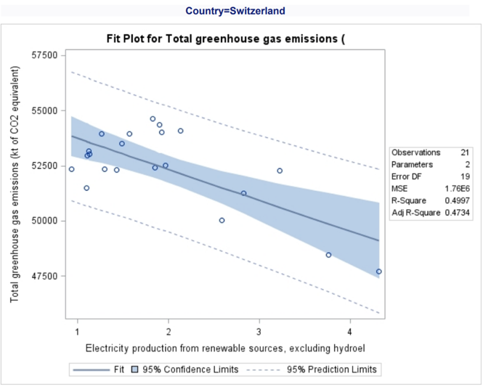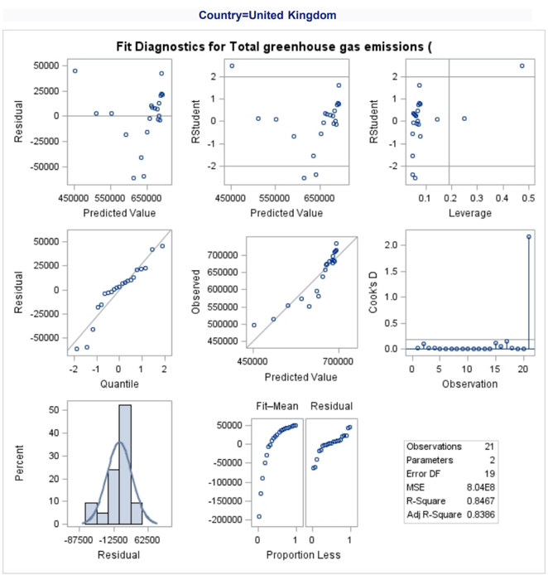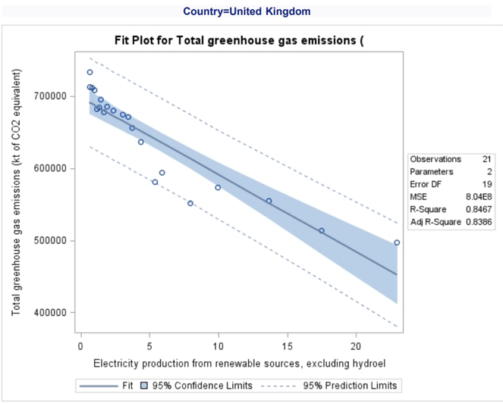

# 4-3 Discussion

Taking Sweden as an example, the regression diagnostic plot and regression plot can be explored. Firstly, looking at the predicted vs observed plot in the middle of the diagnostic figure, the quality of the predictive model can be seen. For this model, the data fits well as the points fit close to the diagonal line. There is one outlier marked by the red circle where the observed doesn’t match the predicted. This outlier is due to a large residual.

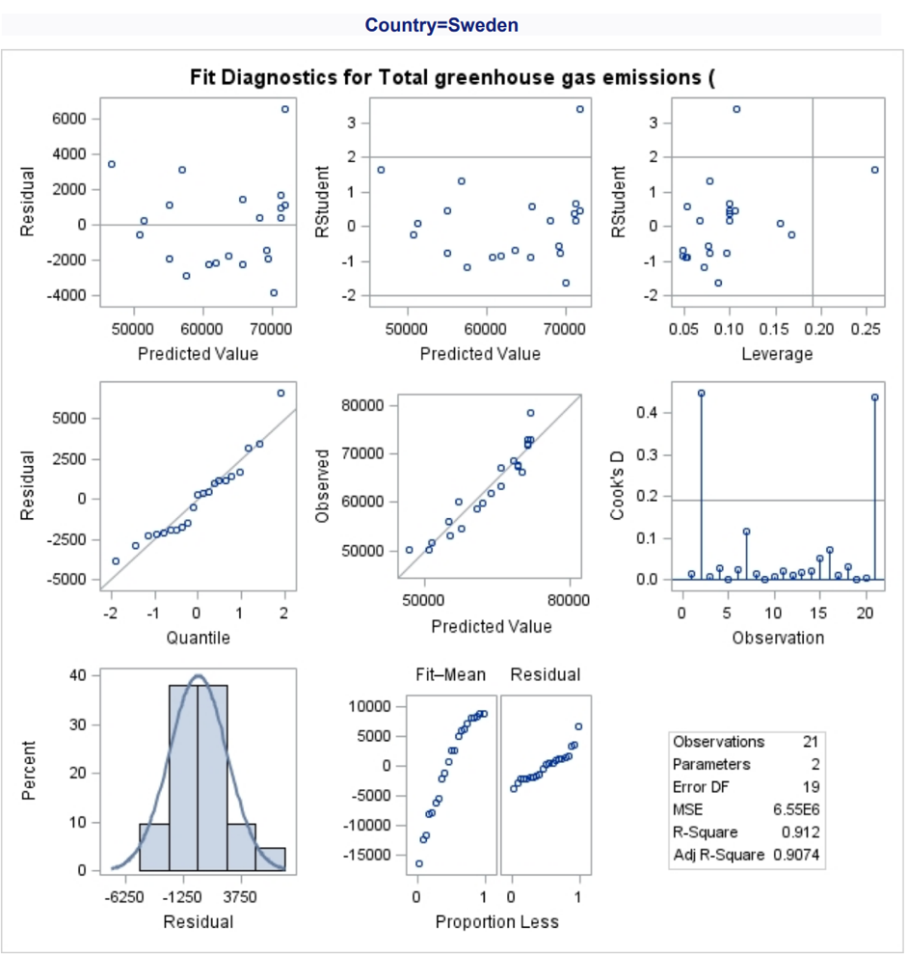

Next the raw residuals and the (externally) studentized residuals for the observations can be explored. This is done by looking at the residual plots seen in the top left of the diagnostic figure. The first graphs are the raw residuals vs the predicted values. This graph should ideally look random and have no patterns. If the graph shows some sort of curve, then more effects may need to be added to the model to capture the full and all the signal in the response variable. In addition, if this graph shows a fan shape, then it indicates that the residuals don’t have constant variance. Lastly, if the residuals are not randomly scattered then they are not independent. For our example in Sweden, we see no curve, fan shape or pattern showing that the residuals are a set of independent and identically distributed random variables. Looking at the next plot, the studentized residual, any outliers can be seen. If the magnitude of the RStudent is greater than 2 or less than -2, the observation needs to examine further as a possible outlier. In the Sweden example, there is one possible outlier seen with a large positive residual. This same point is observed as an outlier in the predicted vs observed plot.



The next plots are the studentized residuals versus the leverage value for each observation and the needle plot of Cook's D. The first plot allows for the investigation of outliers and the second indicates influential observations. The leverage statistic tries to find out which observations are the most influential. The leverage statistic shows how far away an observation is from the data's centroid. It’s seen in the first plot that there are two distinct observations, one with the high Rstudent value in the top left quadrant and one with the high leverage value seen in the bottom right quadrant. The top left quadrant indicates an outlier but not a high leverage value and the bottom right quadrant indicates not an outlier but a high leverage value. The Cook’s D plot indicate there is two values that are highly influential on the model. These two points negatively affect the regression plot (Stephanie, 2016).



The next two plot that are observed are used to look at the normality of the residuals and to see if the data is normally distributed. The first plot is a QQ-plot where if the observed residuals lie on the diagonal line, then the data is approximately normal. For the Sweden QQ-plot, all but a few points lie on the line indicating there is outliers in the data which is has been seen before. However, for this model, the residuals are approximately normal; the overlay of the normal density curve does fit the histogram well.



Lastly the spread plot which shows weather the spread of the residuals and the fit values are comparable. In our Sweden example, it can be concluded that the spread of the residual values is small relative to the spread of the fitted values since the fitted values, or the left plot are taller than the residual plot or the right plot.



# 4-4

Chi Square test:

The Chi Square test determines how strong a relationship between two category variables is. The chi-squared statistic is a single value that reflects the amount of difference between the counts you saw and the counts you would expect if the population had no association at all. If the calculated chi-square value is more than the critical value, then there is a significant difference (Statistics How To, 2022). The null hypothesis of the Chi-Square test is that the categorical variables in the population have no relationship or in other words, they are independent. This test statistics will test if two variables are associated between each other but not how closely they are associated. Therefore, other test statistics will need to be used to how strong one variable is associated with another (Rana & Singhal, 2015). The Chi Square test statistic,

$$χ^{2}=\frac{Σ{\left(O-E\right)}^{2}}{E}$$

Where *O* is the observed value and *E* is the expected value under a null hypothesis which is calculated by,

$$E=\frac{Row Total*Column Total}{Sample Size}$$

We will compare the value of the test statistic to the critical value of $χ_{a}^{2}$  with degree of freedom = (*r* - 1) (*c* - 1) and reject the null hypothesis if ${χ^{2}>χ}_{a}^{2}$  (PennState, 2022). Some assumptions of the chi square test include,

* The sample population is drawn at random.
* The minimum sample size is between 20-50.
* The variables under testing must be mutually exclusive.

Z-test:

When the variances are known and the sample size is large, a z-test is used to assess whether two population means are different (Chen, Z-Test, 2021). A z-test is a hypothesis test with a normal distribution for the z-statistic. A z-statistic, also known as a z-score, is a numerical representation of the result of a z-test. Z-tests are comparable to t-tests, although t-tests are better suited to trials with a small sample size. The z-test is best used for samples with more than 30 since the central limit theorem indicates that as the number of samples rises, the samples are presumed to be roughly normally distributed (Chen, Z-Test, 2021).

t-test:

A t-test is a technique that is used to see if there is a significant difference in the means of two groups that are related in some way. A t-test requires the computation of three primary data values. They contain the mean difference (the difference between each data set's mean values), each group's standard deviation, and the number of data values in each group. Comparing more than two groups would require the use of ANOVA hypothesis testing (Hayes, 2022). The formula for the t- test is,

$$t=\frac{Mean_{1}-Mean_{2}}{\sqrt{\frac{Var_{1}}{n_{1}}-\frac{Var_{2}}{n_{2}}}}$$

When the outputted t-test value is greater than the p-value calculated in software like SAS or found in statistical tables, then the null hypothesis is rejected and there is a difference between the means.

Sign Test:

Test if two variables are different ignoring magnitude of change and only considering the direction. The sign test is a nonparametric test that compares the size of two groups or samples. It’s an alternate test to the t-test and can be used to rank categorical data. For this test, the null hypothesis is that there is zero difference between the two medians. To perform the sign test, firstly the two groups are subtracted, and the difference is calculated. Next the number of positive and negative differences are totalled and the total sample size minus 1 will give the number of trails or n value for the test. Then using the binomial probability tables at a probability of 0.5, the p value can be calculated. When using the tables, the x value on the left-hand side, is the number of successful trails. Lastly, the newly found p value is compared to an alpha value, usually 0.05. If the p value is less than the alpha value, then you reject the null hypothesis. An example of the sign test is to find if customers prefer product A or product B.

For this part, two hypotheses will be created and tested using the program SAS on the dataset. By going to File>New>Program, a blank program will appear where code can be written. The following code is written to complete this objective,

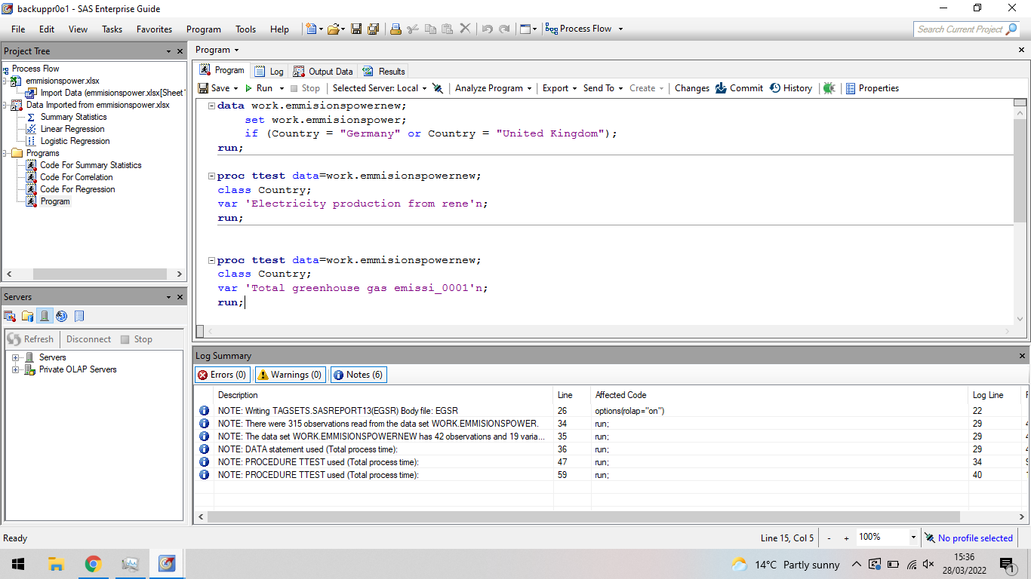

Before the Hypothesis testing could be coded, a newly formed dataset based of the main data will be created. In this new data, just the countries Germany and the United Kingdom will be extracted using the IF command. Next a t-test procedure on the new dataset is done for the two countries and modelled on the variable chosen.

Hypothesis 1: Is there a difference between the use of renewable electricity between two of the most powerful countries in Europe, Germany, and the United Kingdom?

Hypothesis 2: Is there a difference between the CO2 consumption between the two superpowers of Europe, Germany, and the United Kingdom?

For these hypotheses, a two tailed z test could be used however due the sample size being below 30, another test will be used. Instead, the t test will be used to compare the two groups. will be used at an alpha value of 0.05 which is the standard alpha value. Two tailed test is use because the hypothesis is to measure if there is any difference and not if one country produces more or less than the other.

Hypothesis 1:

H0: There is no difference in the renewable energy use from the respective countries.

H1: There is a difference in the use of renewable energy between the two countries.

$${\overline{x}}_{1}= 9.2889, {\overline{x}}_{2}=5.2686, σ_{1}=8.0734, σ_{2}=6.0671, n_{1}=21, n_{2}=21$$

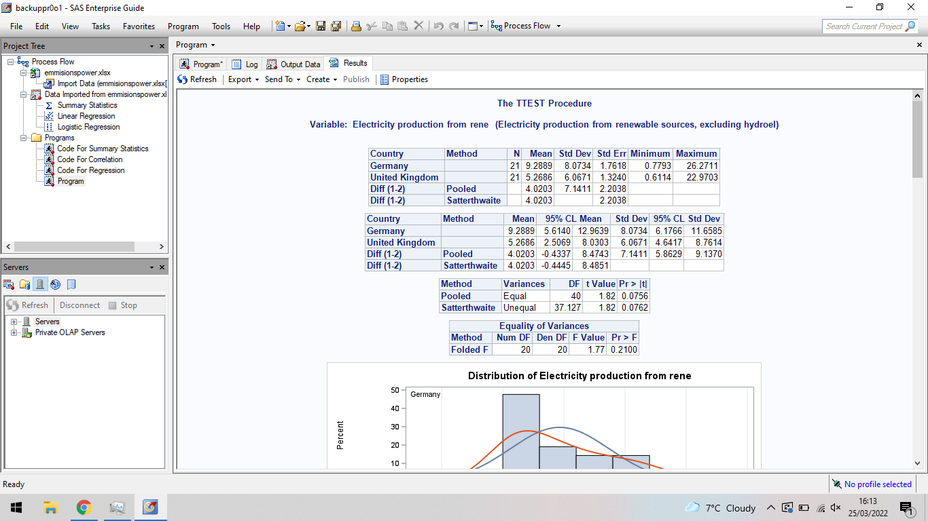

The T-Test between the countries Germany and the United Kingdom produces a t value of 1.82. This t value provides a p value that of 0.0756 which is greater than the significance level of 0.05 thus H0 is rejected. H0 is rejected therefore there is a difference between the two superpowers in their use in renewable energy over the 21 years.

Hypothesis 2:

H0: There is no difference in the change in the greenhouse gas production compared to year of 1990 of the respective countries.

H1: There is a difference in the change in the greenhouse gas production compared to year of 1990 of the two countries.

$${\overline{x}}_{1}= 9.2889, {\overline{x}}_{2}=5.2686, σ_{1}=8.0734, σ_{2}=6.0671, n_{1}=21, n_{2}=21$$

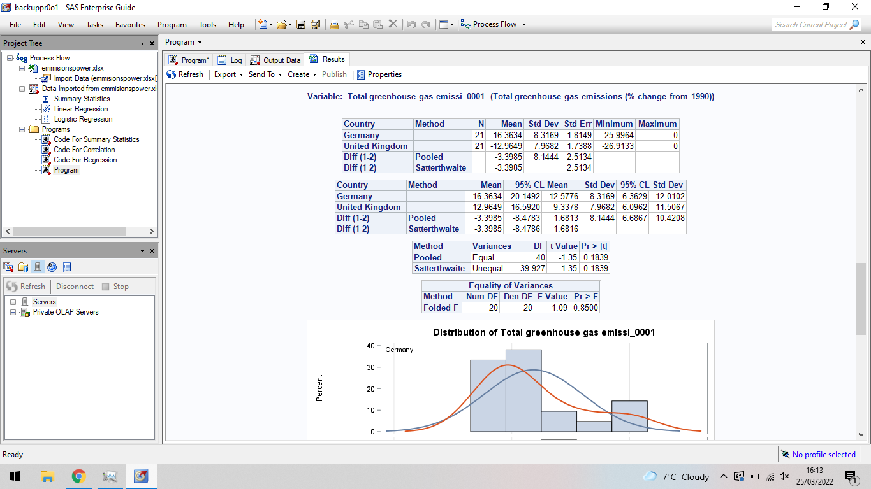

The T-Test between the countries Germany and the United Kingdom produces a t value of -1.35. This t value provides a p value that of 0.1839 which is greater than the significance level of 0.05 thus H0 is rejected. H0 is rejected therefore there is a difference between the two superpowers in their production in the greenhouse gases over the 21 years.

# Conclusions

To conclude, during this part, a statistical analysis was performed over the 18 variables and 15 countries using the software SAS. This section included 4 parts, a comprehensive statistical overview of the data where the mean, median, mode, skewness, kurtosis, min, max and standard deviation was discovered for all the variables. It was found that Germany produces on average the most C02 emissions and Luxembourg the least. Compared to Germany’s nearest competitor, the United Kingdom, on average Germany still created a massive 37.7% more C02 gas. In addition, Germany has the biggest decrease since 1990 and Portugal have the greatest increase. Portugal greenhouse gases have increased by 32.1% since 1990. On average the biggest producer of renewable energy is the country Denmark having 25.8% of its electricity produced by renewable sources. Denmark also exports the most electricity. Furthermore, Spain and Portugal have large standard deviation for the change in the percentage greenhouse gases compared to 1990 value. Indicating a large spread of values and large fluctuation in the percentage change for these countries, there is no stable change. In the next part, a correlation analysis was conducted on the amount of greenhouse gases produced by the country and the use of renewable sources for electricity production. It was found that a negative correlation is seen in all countries however, the correlation is more negative in some indicating that the renewable source variable has a stronger effect on the greenhouse gases. The UK, Sweden, Netherlands, Italy, Germany, France, Denmark, and Belgium all have very strong negative correlation. This also indicate that if these countries focus on using renewable sources for electricity creation, they could reduce their greenhouse gases emissions effectively. Part 3 of the statistical analysis included a regression analysis. As a scenario, Sweden is analysed and it is found that in the observed vs predicted plot, there was one outlier due to large residuals but otherwise, most points matched what the regression analysis predicted. This same outlier is seen in the residual plot and can been seen to be large and positive. Furthermore, in the Cook’s D plot indicate there is two values that are highly influential on the model. These two points negatively affect the regression plot. However, for this model, the residuals are approximately normal; the overlay of the normal density curve does fit the histogram well. Lastly, in our Sweden example, it can be concluded that the spread of the residual values is small relative to the spread of the fitted values. Finally, part 4, a statistical comparative analysis of the hypothesis testing approaches was completed looking at the t-test, z-test, chi square test, sign test and other hypothesis testing like the ANOVA was mentioned. In this part two hypothesis based of the data and objectives were explore, the first if there is a difference between the use of renewable electricity between two of the most powerful countries in Europe, Germany, and the United Kingdom and the second, Is there a difference between the CO2 consumption between the two superpowers of Europe, Germany, and the United Kingdom. It was found for both hypotheses, that there is a difference.

# References

Akaho, S. (2007). *A kernel method for canonical correlation analysis.* Tsukuba: AIST Neuroscience Research Institute.

Bakar, N. M., & Tahir, I. M. (2009). Applying Multiple Linear Regression and Neural Network to Predict Bank Performance. *International Business Research* .

C.Chiang, T., Nam Jeon, B., & Li, H. (2007). Journal of International Money and Finance. *Dynamic correlation analysis of financial contagion: Evidence from Asian markets*, 1206-1228.

Center for Resource Solutions . (2020, January 1). *Why Renewable Energy*. Retrieved from Center for Resource Solutions : https://resource-solutions.org/why-renewable-energy/

Chen, J. (2021, November 07). *Z-Test*. Retrieved from investopedia: https://www.investopedia.com/terms/z/z-test.asp

Chen, J. (2021, November 7). *Z-Test*. Retrieved from investopedia: https://www.investopedia.com/terms/z/z-test.asp#:~:text=The%20z%2Dtest%20is%20also,to%20be%20approximately%20normally%20distributed.

Craig, W. (n.d.). *How to Make Data Visualization Better with Gestalt Laws*. Retrieved from Web FX: https://www.webfx.com/blog/web-design/data-visualization-gestalt-laws/

Data Crunch. (2021, January 1). *Using Tableau Actions to Create Interactive Dashboards*. Retrieved from Data Crunch: https://datacrunchcorp.com/tableau-action/

E. Atkinson, J. (1978). Correlation analysis of the physiological factors controlling fundamental voice frequency. *The Journal of the Acoustical Society of America*.

Energy.gov. (2014, June 20). *How a Wind Turbine Works*. Retrieved from Department of Energy: https://www.energy.gov/articles/how-wind-turbine-works

Energy.gov. (2020, january 1). *How Do Wind Turbines Work?* Retrieved from OFFICE OF ENERGY EFFICIENCY & RENEWABLE ENERGY: https://www.energy.gov/eere/wind/how-do-wind-turbines-work

Engineering Statistical Handbook. (n.d.). *Measures of Skewness and Kurtosis*. Retrieved from Engineering Statistical Handbook: https://www.itl.nist.gov/div898/handbook/eda/section3/eda35b.htm

Engineering Statistical Handbook. (n.d.). *Measures of Skewness and Kurtosis*. Retrieved from Engineering Statistical Handbook: https://www.itl.nist.gov/div898/handbook/eda/section3/eda35b.htm

EWEA. (2016, December 31). *Wind energy's frequently asked questions (FAQ)*. Retrieved from The European Wind Energy Association: https://www.ewea.org/wind-energy-basics/faq/

Falk, M., Marohn, F., & Tewes, B. (1995). Regression Analysis. *Foundations of Statistical Analyses and Applications with SAS*, 87-138.

GeckoBoard. (2020, August 19). *6 Data visualization techniques to display your key metrics*. Retrieved from GeckoBoard: https://www.geckoboard.com/blog/6-data-visualization-techniques-to-display-your-key-metrics/

Gogtay, N., & Thatte, U. (2017). Principles of Correlation Analysis . *Journal of The Association of Physicians of India*, 78-82.

Hardoon, D. R., & Shawe-Taylor, J. (2009). Convergence analysis of kernel Canonical Correlation Analysis: theory and practice. *Mach Learn*, 23-38.

Hayes, A. (2022, March 12). *T-test*. Retrieved from investopedia: https://www.investopedia.com/terms/t/t-test.asp

Ko, I., & Chang, H. (2017). Interactive Visualization of Healthcare Data Using Tableau. *Helthcare Imformatics Research* , 349-354.

Kriebel, A. (2017). *A New Way to Visualize an Income Statement* . Retrieved from VizWiz: https://www.vizwiz.com/2017/07/income-statement.html

MAJASKI, C. (2021, October 28). *Hypothesis Testing*. Retrieved from investopedia: https://www.investopedia.com/terms/h/hypothesistesting.asp#:~:text=Hypothesis%20testing%20is%20an%20act,hypothesis%20by%20using%20sample%20data

Mialki, S. (2021, July 14). *What Is the Z-Pattern Layout & When to Use It?* Retrieved from instapage: https://instapage.com/blog/z-pattern-layout

PennState. (2022). *Chi-Square Test of Independence* . Retrieved from PennState Eberly College Of Science: https://online.stat.psu.edu/statprogram/reviews/statistical-concepts/chi-square-tests

Poliak, E. I., Shim, M. K., Kim, G. S., & Choo, W. Y. (1998). Application of linear regression analysis in accuracy assessment of rolling force calculations. *Metals and Materials*, 1047–1056.

Pont, S. D. (2022, January 1). *DESIGNING A DASHBOARD IN TABLEAU FOR BUSINESS INTELLIGENCE*. Retrieved from General Assembly : https://generalassemb.ly/blog/designing-dashboard-tableau-business-intelligence/

Rana, R., & Singhal, R. (2015). Chi-square test and its application in hypothesis testing. *STATISTICAL PAGES*, 69-71.

Smarter Business. (2019, July 18). *UK renewable energy percentage 2018 & 2019*. Retrieved from Smarter Business: https://smarterbusiness.co.uk/blogs/uk-renewable-energy-percentage-2018/

Statistics How To. (2022). *Chi-Square Statistic: How to Calculate It / Distribution*. Retrieved from Statistic How To: https://www.statisticshowto.com/probability-and-statistics/chi-square/

Stephanie. (2016, July 13). *Cook’s Distance / Cook’s D: Definition, Interpretation*. Retrieved from Statistics How To: https://www.statisticshowto.com/cooks-distance/

Sykes, A. O. (1993). *An Introduction to Regression Analysis.* Chicago: University of Chicago Law School.

Tableau. (2021). *Get Started with Calculations in Tableau*. Retrieved from Tableau: https://help.tableau.com/current/pro/desktop/en-us/calculations_calculatedfields_create.htm

Tableau. (n.d.). *6 real-world examples of business intelligence dashboards*. Retrieved from Tableau: https://www.tableau.com/en-gb/learn/articles/business-intelligence-dashboards-examples

TopCoder. (2019, August 1). *GESTALT PRINCIPLES FOR DATA VISUALIZATION*. Retrieved from TopCoder: https://www.topcoder.com/blog/gestalt-principles-for-data-visualization/

Upasana. (2021, December 19). *Understanding How And When To Use Different Tableau Charts*. Retrieved from edureka!: https://www.edureka.co/blog/tableau-charts/#Maps

Wang, Q., Ni, J., & Tenhunen, J. (2005). Application of a geographically-weighted regression analysis to estimate net primary production of Chinese forest ecosystems . *Global Ecology and Biogeography*.